Table 1S. The parameters investigated, their respective codes, mean values, standard deviation and coefficient of variation.

Parameter | Parameter code | Average value ± standard deviation | Coefficient of variation
Weekly shoot growth in length [cm] | SGLwk | 54.656 ± 4.319 | 7.9%
Distance from shoot top to 1st open flower [cm] | DTF | 67.719 ± 3.342 | 4.9%
Shoot diameter at the top 1 week earlier [mm] | SD1 | 6.258 ± 0.426 | 6.8%
Shoot diameter at the top 2 weeks earlier [mm] | SD2 | 6.578 ± 0.355 | 5.4%
Number of fully grown leaves per plant [pcs.] | NoL | 21.875 ± 1.06 | 4.8%
Number of flowers per shoot [pcs.] | NoF | 1.667 ± 0.322 | 19.3%
Number of fruits set on the shoot [pcs.] | NoFS | 17.938 ± 3.877 | 21.6%
Number of fruits harvested per week [pcs.] | NoFwk | 3.188 ± 0.304 | 9.5%
Weight of fruit harvested per week [g] | WFwk | 767.813 ± 83.992 | 10.9%
Leaf length [cm] | LL | 37.474 ± 4.065 | 10.8%
Leaf width [cm] | LW | 34.339 ± 3.142 | 9.1%
Leaf area [cm²] | LA | 1,299.969 ± 248.948 | 19.2%
Plate length [cm] | PL | 13.281 ± 2.577 | 19.4%
Index of relative chlorophyll content [SPAD unit] | SPAD | 45.632 ± 1.496 | 3.3%
Leaf area index [LAI unit] | LAI | 2.437 ± 0.785 | 32.2%
Mean tilt angle [°] | MTA | 62.875 ± 1.658 | 2.6%
Dry mass [%] | DM | 11.432 ± 1.178 | 10.3%
Total soluble solids [°Brix] | Brix | 5.489 ± 1.018 | 18.5%
Lutein [mg.100 g^{–1}(FM)] | Lutein | 8.215 ± 2.371 | 28.9%
Chlorophyll b [mg.100 g^{–1}(FM)] | Chl.b | 27.668 ± 7.674 | 27.7%
Chlorophyll a [mg 100 g^{–1}(FM)] | Chl.a | 96.037 ± 25.762 | 26.8%
α-carotene [mg 100 g^{–1}(FM)] | aCar | 0.154 ± 0.091 | 59.1%
β-carotene [mg 100 g^{–1}(FM)] | bCar | 13.434 ± 4.215 | 31.4%

Table 2S. Pearson correlation matrix: values above the diagonal for young leaves, values below the diagonal for mature leaves. * significance of the Pearson correlation coefficient at the alpha level = 0.05, ** significance of the Pearson correlation coefficient at the alpha level = 0.01.

 | Lutein | Chl.b | Chl.a | aCar | bCar | LL | LW | LA | PL | SPAD | SGLwk | DTF | SD1 | SD2 | NoL | NoF | NoFS | NoFwk | WFwk | LAI | MTA | DM | Brix
Lutein |  | 0.951** | 0.984** | 0.772* | 0.964** | –0.384 | –0.267 | –0.327 | –0.364 | –0.367 | 0.822* | 0.634 | –0.124 | 0.127 | 0.893** | 0.870** | –0.636 | 0.221 | 0.140 | –0.125 | –0.186 | –0.352 | –0.820*
Chl.b | 0.990** |  | 0.973** | 0.641 | 0.944** | –0.314 | –0.225 | –0.275 | –0.270 | –0.458 | 0.807* | 0.715* | –0.196 | 0.040 | 0.785* | 0.734* | –0.551 | 0.110 | 0.026 | –0.156 | –0.041 | –0.185 | –0.792*
Chl.a | 0.979** | 0.997** |  | 0.772* | 0.977** | –0.380 | –0.278 | –0.329 | –0.350 | –0.379 | 0.816* | 0.622 | –0.084 | 0.188 | 0.878** | 0.854** | –0.610 | 0.105 | 0.030 | –0.093 | –0.190 | –0.382 | –0.868**
aCar | 0.760* | 0.737* | 0.707* |  | 0.835** | –0.678 | –0.600 | –0.631 | –0.667 | 0.131 | 0.493 | 0.216 | –0.123 | 0.331 | 0.927** | 0.804* | –0.799* | –0.105 | 0.039 | –0.207 | –0.385 | –0.804* | –0.779*
bCar | 0.971** | 0.978** | 0.969** | 0.846** |  | –0.557 | –0.464 | –0.513 | –0.521 | –0.201 | 0.714* | 0.509 | –0.235 | 0.146 | 0.942** | 0.814* | –0.760* | –0.018 | –0.039 | –0.277 | –0.088 | –0.458 | –0.881**
LL | –0.769* | –0.807* | –0.818* | –0.410 | –0.777* |  | 0.988** | 0.996** | 0.991** | –0.675 | 0.140 | 0.294 | 0.586 | –0.066 | –0.699 | –0.337 | 0.919** | 0.547 | 0.376 | 0.734* | –0.220 | 0.609 | 0.576
LW | –0.598 | –0.646 | –0.658 | –0.232 | –0.617 | 0.948** |  | 0.996** | 0.975** | –0.729* | 0.256 | 0.366 | 0.611 | –0.061 | –0.598 | –0.222 | 0.863** | 0.638 | 0.434 | 0.751* | –0.258 | 0.568 | 0.503
LA | –0.705 | –0.749* | –0.761* | –0.342 | –0.720* | 0.991** | 0.983** |  | 0.982** | –0.699 | 0.193 | 0.318 | 0.626 | –0.031 | –0.649 | –0.265 | 0.900** | 0.587 | 0.399 | 0.768* | –0.270 | 0.570 | 0.529
PL | –0.732* | –0.715* | –0.700 | –0.464 | –0.705 | 0.892** | 0.797* | 0.860** |  | –0.700 | 0.183 | 0.348 | 0.526 | –0.131 | –0.680 | –0.370 | 0.888** | 0.522 | 0.369 | 0.678 | –0.158 | 0.627 | 0.579
SPAD | 0.447 | 0.534 | 0.564 | 0.501 | 0.617 | –0.634 | –0.588 | –0.630 | –0.372 |  | –0.737* | –0.805* | –0.345 | –0.031 | 0.038 | –0.266 | –0.400 | –0.668 | –0.480 | –0.510 | 0.264 | –0.460 | 0.027
SGLwk | 0.105 | –0.015 | –0.069 | 0.112 | –0.039 | 0.144 | 0.263 | 0.204 | –0.279 | –0.651 |  | 0.847** | 0.161 | 0.017 | 0.588 | 0.667 | –0.213 | 0.516 | 0.390 | 0.217 | –0.284 | –0.107 | –0.488
DTF | 0.211 | 0.102 | 0.058 | –0.079 | 0.026 | –0.141 | –0.095 | –0.115 | –0.472 | –0.576 | 0.847** |  | –0.074 | –0.289 | 0.288 | 0.360 | –0.019 | 0.554 | 0.505 | 0.152 | –0.120 | 0.290 | –0.205
SD1 | –0.883** | –0.897** | –0.896** | –0.660 | –0.917** | 0.884** | 0.781* | 0.853** | 0.777* | –0.713* | 0.161 | –0.074 |  | 0.615 | –0.240 | 0.224 | 0.609 | 0.197 | –0.015 | 0.936** | –0.686 | –0.205 | –0.040
SD2 | –0.577 | –0.607 | –0.623 | –0.113 | –0.522 | 0.842** | 0.786* | 0.826* | 0.808* | –0.298 | 0.017 | –0.289 | 0.615 |  | 0.197 | 0.551 | 0.028 | –0.110 | –0.135 | 0.479 | –0.732* | –0.522 | –0.439
NoL | 0.450 | 0.357 | 0.306 | 0.763* | 0.451 | 0.070 | 0.295 | 0.168 | –0.208 | –0.052 | 0.588 | 0.288 | –0.240 | 0.197 |  | 0.824* | –0.876** | –0.037 | –0.013 | –0.353 | –0.136 | –0.649 | –0.841**
NoF | 0.064 | –0.045 | –0.095 | 0.342 | –0.004 | 0.524 | 0.677 | 0.599 | 0.245 | –0.503 | 0.667 | 0.360 | 0.224 | 0.551 | 0.824* |  | –0.501 | 0.227 | 0.142 | 0.164 | –0.562 | –0.569 | –0.836**
NoFS | –0.687 | –0.642 | –0.611 | –0.938** | –0.753* | 0.281 | 0.054 | 0.190 | 0.394 | –0.419 | –0.213 | –0.019 | 0.609 | 0.028 | –0.876** | –0.501 |  | 0.262 | 0.120 | 0.734* | –0.191 | 0.560 | 0.629
NoFwk | 0.048 | 0.016 | 0.022 | –0.362 | –0.152 | 0.046 | 0.154 | 0.097 | –0.046 | –0.508 | 0.516 | 0.554 | 0.197 | –0.110 | –0.037 | 0.227 | 0.262 |  | 0.890** | 0.338 | –0.315 | 0.400 | 0.280
WFwk | 0.083 | 0.057 | 0.069 | –0.308 | –0.073 | –0.084 | 0.049 | –0.025 | –0.152 | –0.232 | 0.390 | 0.505 | –0.015 | –0.135 | –0.013 | 0.142 | 0.120 | 0.890** |  | 0.164 | –0.373 | 0.291 | 0.373
LAI | –0.862** | –0.890** | –0.889** | –0.827* | –0.952** | 0.801* | 0.671 | 0.759* | 0.688 | –0.813* | 0.217 | 0.152 | 0.936** | 0.479 | –0.353 | 0.164 | 0.734* | 0.338 | 0.164 |  | –0.721* | 0.003 | 0.071
MTA | 0.657 | 0.714* | 0.724* | 0.455 | 0.709* | –0.842** | –0.858** | –0.860** | –0.691 | 0.571 | –0.284 | –0.120 | –0.686 | –0.732* | –0.136 | –0.562 | –0.191 | –0.315 | –0.373 | –0.721* |  | 0.445 | 0.216
DM | 0.412 | 0.452 | 0.456 | 0.125 | 0.411 | –0.677 | –0.797* | –0.735* | –0.567 | 0.235 | –0.199 | 0.062 | –0.435 | –0.713* | –0.352 | –0.605 | 0.151 | –0.253 | –0.407 | –0.383 | 0.895** |  | 0.630
Brix | 0.028 | 0.047 | 0.068 | –0.448 | –0.111 | –0.334 | –0.328 | –0.330 | –0.387 | –0.283 | 0.253 | 0.420 | 0.081 | –0.670 | –0.439 | –0.424 | 0.510 | 0.607 | 0.449 | 0.211 | 0.264 | 0.418

Table 3S. Eigenvalues and proportions of total variance explained by the first five principal components. Extraction Method: Principal Component Analysis. Rotation Method: Varimax with Kaiser Normalization.

variable | Component
variable | 1 | 2 | 3 | 4 | 5
SGLwk | 0.275 | 0.055 | 0.211 | 0.868 | 0.223
DTF | 0.203 | 0.031 | –0.149 | 0.840 | 0.338
SD1 | –0.662 | 0.295 | 0.470 | 0.279 | –0.042
SD2 | –0.207 | 0.160 | 0.848 | –0.039 | –0.182
NoL | 0.722 | –0.139 | 0.515 | 0.308 | –0.105
NoF | 0.393 | 0.041 | 0.746 | 0.489 | 0.025
NoFS | –0.835 | 0.255 | –0.285 | 0.086 | 0.144
NoFwk | –0.064 | 0.159 | –0.014 | 0.401 | 0.861
WFwk | 0.013 | 0.080 | 0.048 | 0.163 | 0.969
LL | –0.232 | 0.965 | 0.007 | 0.097 | 0.040
LW | –0.196 | 0.944 | 0.080 | 0.155 | 0.119
LA | –0.228 | 0.957 | 0.084 | 0.124 | 0.056
PL | –0.130 | 0.977 | –0.042 | –0.016 | 0.006
SPAD | 0.348 | –0.388 | –0.128 | –0.773 | –0.118
LAI | –0.709 | 0.308 | 0.339 | 0.390 | 0.111
MTA | 0.317 | –0.201 | –0.809 | –0.178 | –0.297
DM | 0.000 | 0.261 | –0.891 | 0.084 | –0.042
Brix | –0.473 | –0.329 | –0.548 | 0.077 | 0.471
Lutein | 0.902 | –0.202 | –0.107 | 0.217 | 0.115
Chl.b | 0.884 | –0.175 | –0.198 | 0.199 | 0.055
Chl.a | 0.882 | –0.188 | –0.161 | 0.111 | 0.092
aCar | 0.889 | 0.147 | 0.189 | –0.073 | –0.197
bCar | 0.920 | –0.286 | –0.080 | 0.074 | –0.032
Total variance explained – rotation sums of squared loadings
Total | 7.095 | 4.602 | 3.927 | 3.021 | 2.332
% of variance | 30.85 | 20.01 | 17.07 | 13.13 | 10.14
Cumulative % | 30.85 | 50.86 | 67.93 | 81.06 | 91.20

Table 4S. Average content of elements in cucumber plant leaves before introduction of P deficiency (t₀) and on day 28 (t₄) of deficiency. Significant differences, based on Student's t-tests are marked by * (p<0.05) or marked by ** (p<0.01). */** statistical significance compared to the control at time 4 at the level * – 0.05, ** – 0.01.

 | t₀ |  | t₄ (–P) |  | t₄ control
 | young leaf | old leaf | young leaf | old leaf | young leaf | old leaf
N | 4.730 | 5.020 | 4.940* | 4.363* | 5.680 | 5.203
P | 5,396.7 | 6,226.7 | 1,890.0** | 1,610.0** | 5,693.3 | 5376.7
K | 38,433.3 | 43,166.7 | 40,900.0 | 33,300.0 | 45,600.0 | 41,366.7
Ca | 36,400.0 | 58,233.3 | 39,200.0 | 48,633.3 | 47,666.7 | 73,266.7
Mg | 5,806.7 | 7,643.3 | 6,160.0 | 6,446.7 | 7,330.0 | 9,366.7
Na | 309.3 | 306.0 | 274.0 | 268.0 | 297.0 | 304.0
S | 4,833.3 | 6,289.0 | 7,100.0* | 7,833.3* | 4,744.3 | 5,233.3
Fe | 68.07 | 82.90 | 116.00 | 88.07 | 80.50 | 100.77
Mn | 195.0 | 290.0 | 258.0 | 371.0 | 256.7 | 363.3
Cu | 8.240 | 8.797 | 9.080 | 9.687 | 7.793 | 7.817
Zn | 61.37 | 78.40 | 39.60 | 48.60 | 53.70 | 69.70
B | 48.67 | 52.93 | 51.40 | 53.50 | 45.90 | 56.90

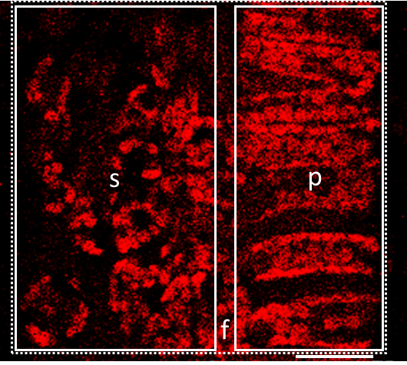
Fig. 1S. Autofluorescence of chlorophyll in palisade and spongy mesophylls of cucumber leaf. Cross-section through the leaf blade. OPSMT curves (see Fig. 8) were recorded for particular regions of interest (marked by rectangles) covering the area of palisade (p), spongy (s) or frame = palisade + spongy mesophyll (f – frame, dotted line). Bar = 30 μm.

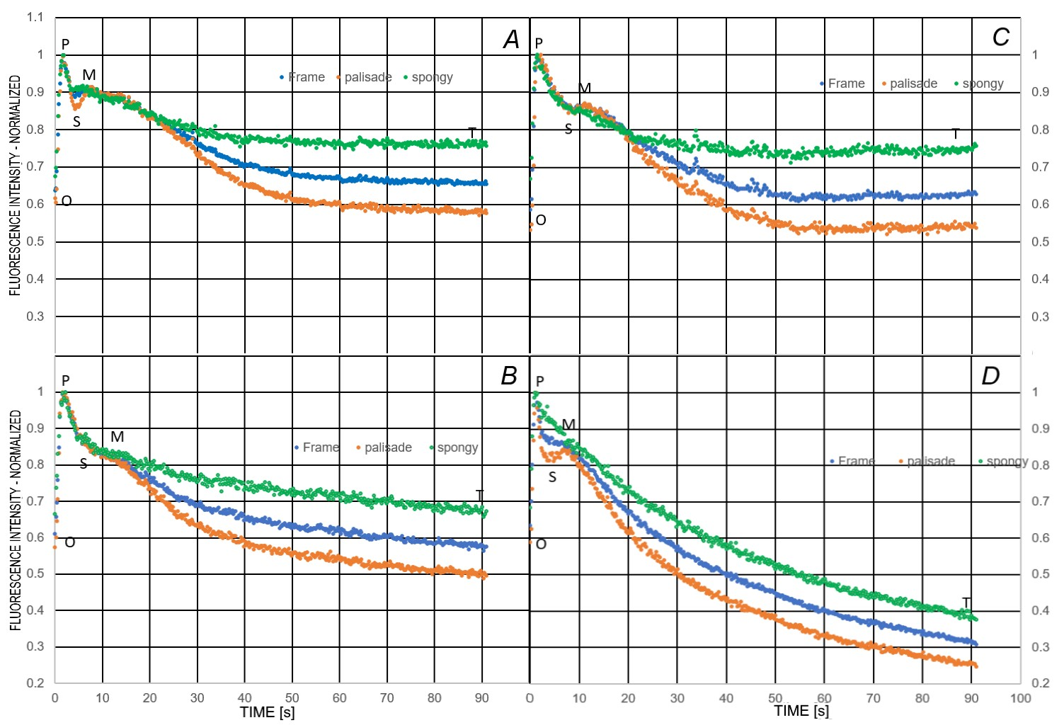

Fig. 2S. OPSMT transients for palisade, spongy or frame = palisade + spongy mesophylls. A and B: young and old leaves of control plants, respectively; C and D: young and old leaves of P-deficient plants, respectively. All transients were averaged and normalized; n = 4.

