Supplement Figures
Phytotoxic effect of silver nanoparticles in Tritium aestivum: Improper regulation of photosystem I activity as the reason for oxidative damage in the chloroplast
Figure S1: The pilot study performed on wheat shows a very clear impact of 1mM and 5mM concentration of AgNPs on plant growth.
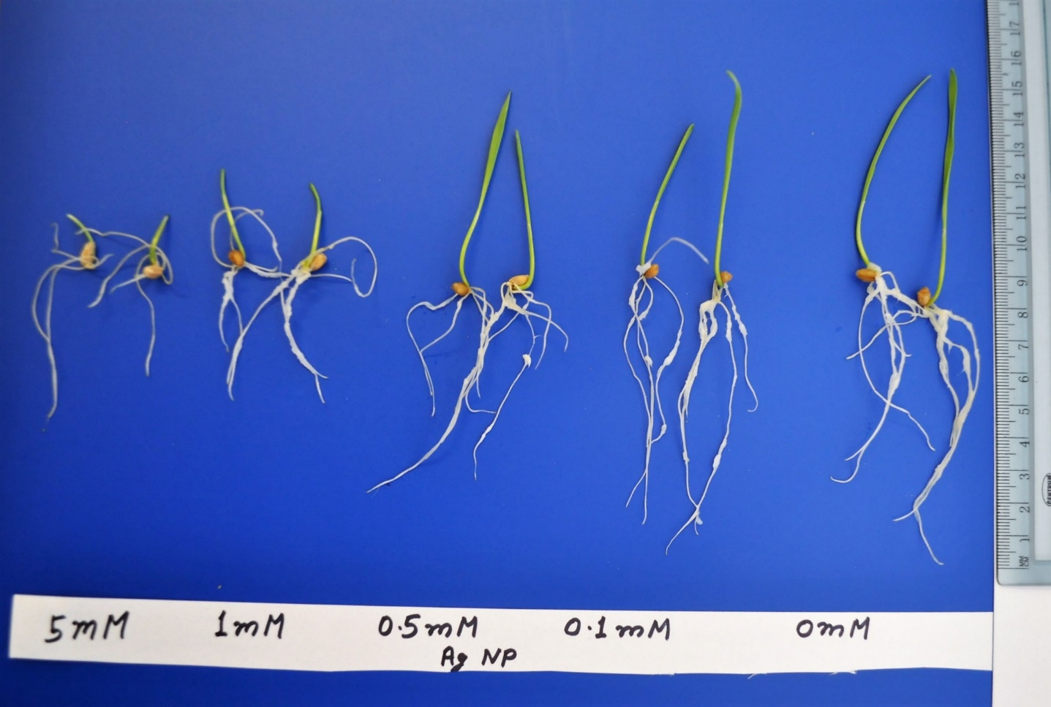

Figure S2: Figure shows that the root avoided its direct contact with filter paper at 5 mM condition of AgNPs.
