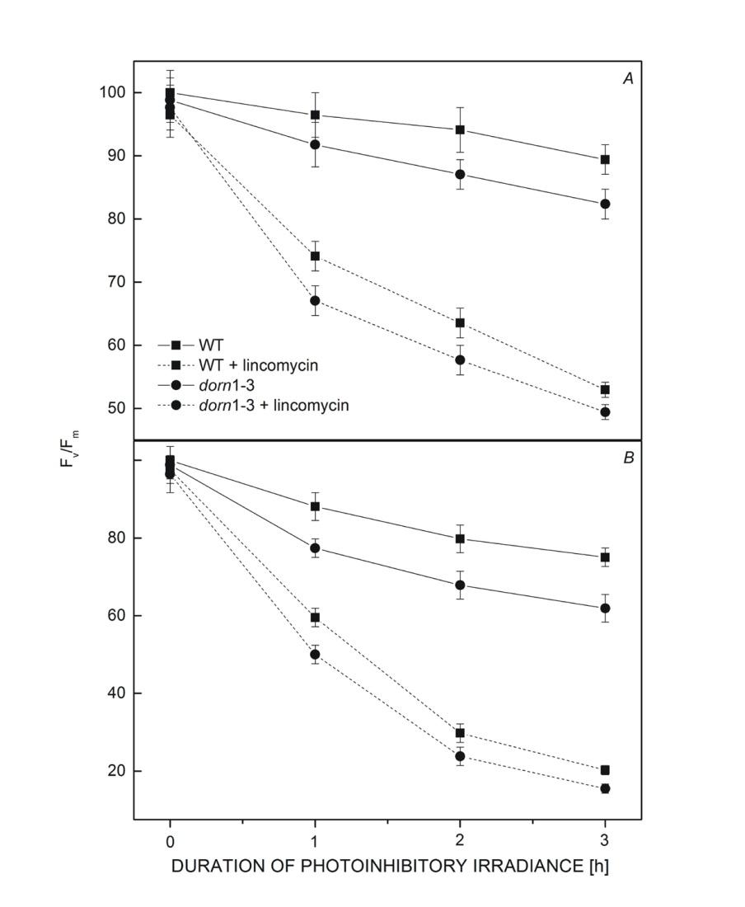
Figure S3. The decrease of F_{v}/F_{m} following high light treatment [400 (A) or 800 (B) μmol m⁻² s⁻¹] in the presence or absence of lincomycin for WT and dorn1-3 mutant leaves. The values represent means of at least four individual experiments. Treatment of lincomycin was performed by immersing the cut end of the petiole of the detached leaves in 0.8 mM lincomycin in water for 3 h prior to photoinhibitory light treatment. All F_{v}/F_{m} values were normalised to the value at time t₀ (about 0.84). F_{v}/F_{m} – maximum quantum efficiency of PSII photochemistry; WT – wild-type.

