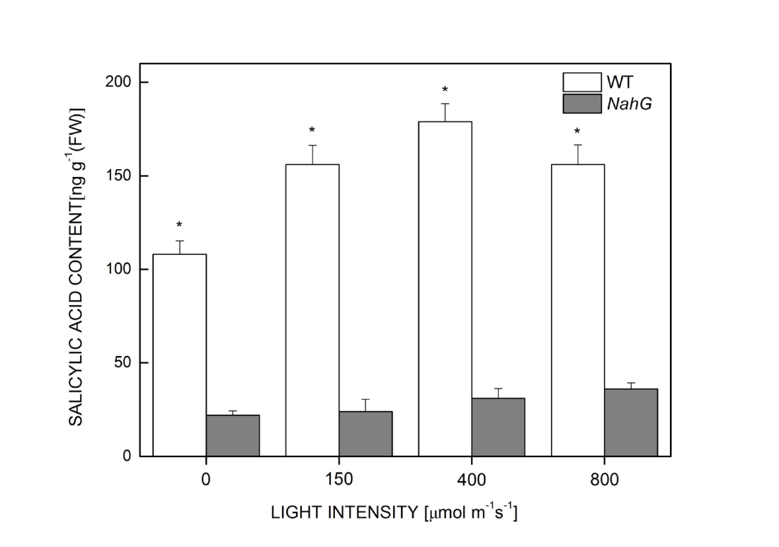
Figure S1. The difference in SA content between WT and NahG transgenic mutant under different light intensities. The values represent means of at least four individual experiments.* - statistically significant differences (at P < 0.05) from the WT and NahG transgenic mutant at the same light intensity. NahG – salicylate hydroxylase gene transgenic mutant; SA – salicylic acid; WT – wild-type.

