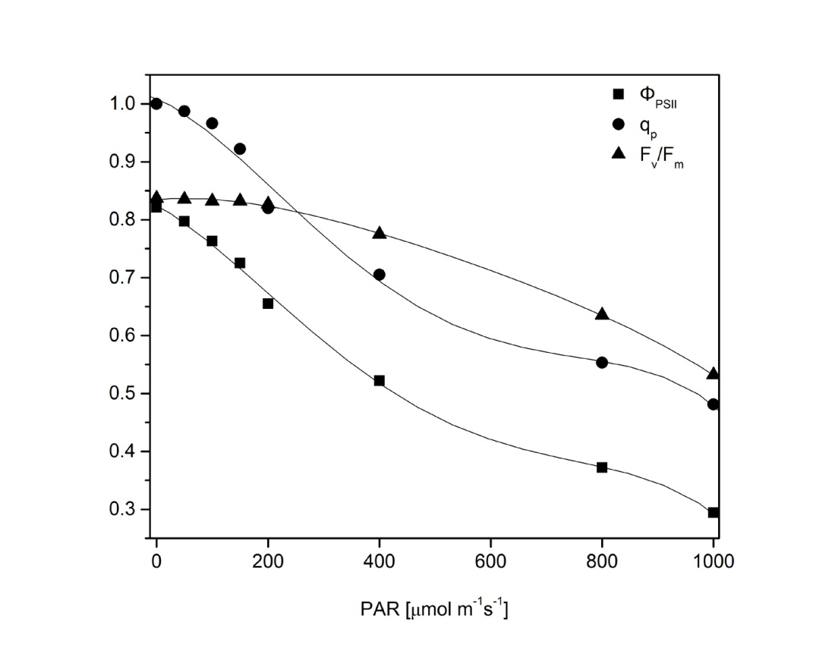
Figure S2. Light response curves of the Φ_{PSII}, q_{p}, and F_{v}/F_{m} of the wild-type plants after treatments with different light intensity. F_{v}/F_{m} – maximum quantum efficiency of PSII photochemistry; PAR – photosynthetically active radiation; q_{p} – photochemical quenching; Φ_{PSII} – the PSII operating efficiency.

