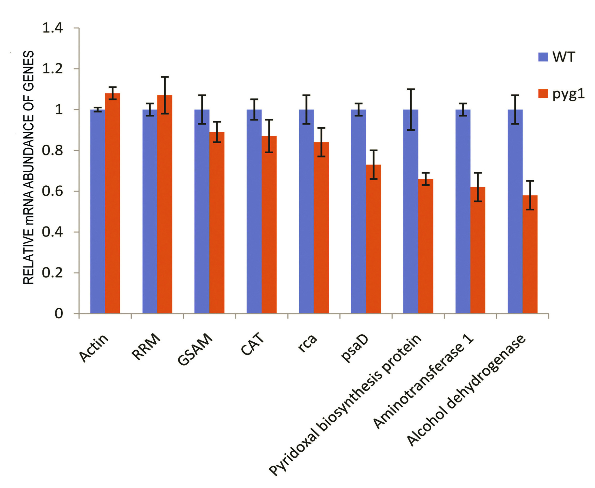
Fig. 1S. qRT-PCR relative mRNA abundance of genes significantly differentially expressed at protein level.

Table 1S. Proteins with significant fold abundance changes in pyg1 mutant. Fold abundance changes ratios are log₂ values which are greater than ±2.0 and p<0.05 (Y – pyg1, G –WT ).

Protein IDs | Gene ID  (NCBI Genebank) | Protein names | Fold change log₂ (Y/G）
>tr|B7SHL1  >tr|B7FDE5  >tr|C5J0I3  >tr|Q8VWX9  >sp|P32869  >tr|Q17UC0  >tr|C6L817  >tr|O82428  >tr|E5GB64  >tr|E5GBL8  >tr|A2TJV6  >tr|E5GB47  >tr|E5GBW3  >tr|Q39558  >tr|Q93XR3  >tr|E5GBH5  >sp|Q2QD78  >tr|E5GBV2  >tr|Q9M4U9  >tr|G3ETR9  >sp|Q4VZM8  >tr|E5KUE1  >tr|Q9MV68  >tr|E5GB87  >tr|Q8H9E2  >tr|B6DQ61  >tr|E5GC77  >tr|E5GBJ5  >tr|Q9M4E7  >tr|G3ETT3  >tr|Q9FV17  >tr|G3ETW1  >tr|E5GBV8  >sp|Q42669  >tr|G3ETU7  >sp|Q4VZK5  >tr|H6TB35  >tr|A8JP99  >tr|E5GBN6  >tr|W8E6U8  >tr|Q0H394  >tr|Q39640  >sp|Q2QDA6  >sp|Q05045  >tr|K9JA38  >sp|P17783  >tr|E5GBR6  >tr|Q9SXL7  >sp|P19446  >sp|Q4VZL1  >tr|Q8RW69  >tr|G3ETX4  >tr|E5GC65  >tr|T1SC37  >sp|P49608  >tr|A1BQK6  >tr|I7K435  >sp|Q9M5I8  >sp|Q9XF61  >tr|A1BQH1  >tr|Q9FRW1  >sp|Q4VZN1  >tr|E5GCF1  >tr|G8EX76  >sp|P13443  >tr|E5LG77  >tr|J9XXT8  >tr|I1Z8C8  >sp|Q4VZP5  >tr|B0F825  >tr|D5I3F1  >sp|Q4VZH3  >sp|P48350  >tr|G0ZS06  >tr|E5GBP8  >tr|A0A060AEY8  >tr|C0LSP3  >tr|E5GBF5  >tr|E5GBJ6  >tr|Q6V1W5  >tr|E5GCQ7 | 101206555  CAP59449.1  101206383  AAL35979.1  101207214  101221846  XP_004149479.1  AAC62207.1  XP_008467032.1  ADN33858.1  ABM92419.1  XP_008459930.1  XP_008439388.1  CAA53700.1  103495195  XP_004150268.1  ABI98756.1  ADN33951.1  103497260  11123109  3429312  10043780  AAF70235.1  XP_008447621.1  XP_023002552.1  ACI16507.1  XP_008441387.1  XP_008446208.1  101210925  11123123  101210925  11123123  XP_008439408.1  11123132  11123148  3429292  11123148  3429292  XP_008443248.1  101221783  XP_008461300.1  18490655  3429310  XP_023006256.1  101222673  3429310  XP_008455731.1  101222673  ABK55707.1  3429309  101211294  11123060  3429309  101211294  11123060  ABK55707.1  101221828  103483849  Q9XF61.1  101221828  103483849  3429291  ADN34150.1  101215805  3429291  101215667  101215805  101209132  101215667  101208202  101210008  3429379  P48350.1  9072846  3429315  AIA61608.1  ACN63365.1  XP_004137720.1  XP_008446207.1  103492000  XP_008455107.1 | Putative RNA recognition motif-containing protein  Lipoxygenase  Chloroplast Rubisco activase, chloroplastic  Extensin-like protein (Fragment)  PSAD_CUCSA Photosystem I reaction center subunit II, chloroplastic  Cinnamate-4-hydroxylase  Putative protoporphyrinogen IX oxidase (Fragment)  Rubisco activase  Dynamin  ATP-dependent clp protease  Chloroplast HSP70  Eukaryotic peptide chain release factor subunit  Nucleoside diphosphate kinase  14-3-3 protein 32kDa endonuclease  Fatty acid 9-hydroperoxide lyase  Tubulin alpha chain  Photosystem I assembly protein Ycf4  Adenylate kinase  L-galactono-1,4-lactone dehydrogenase  30S ribosomal protein S18, chloroplastic  30S ribosomal protein S19, chloroplastic  30S ribosomal protein S7, chloroplastic  Ribulose 1,5-bisphosphate carboxylase large subunit (Fragment)  Helicase  Thioredoxin  Glutathione peroxidase (Fragment)  Ribulose bisphosphate carboxylase/oxygenase activase 1  Carbonic anhydrase  Heat shock protein 70  30S ribosomal protein S8, chloroplastic  NADP-dependent glyceraldehyde 3-phosphate dehydrogenase A subunit  Protein Ycf2  Glyceraldehyde-3-phosphate dehydrogenase  Aconitate hydratase (Fragment)  50S ribosomal protein L32, chloroplastic  ribosomal protein L2, chloroplastic  HSP27.8  Plasma membrane proton pump  DNA-binding protein (Fragment)  DNA-directed RNA polymerase  Carotenoid cleavage dioxygenase leavage dioxygenase (Fragment)  Glycolate oxidase  30S ribosomal protein S16, chloroplastic  Chaperonin CPN60-1  Pyrophosphatase  dehydrogenase  Cysteine synthase  Csf-3 protein  Malate dehydrogenase  30S ribosomal protein S15, chloroplastic  Isocitrate dehydrogenase [NADP]  30S ribosomal protein S2, chloroplastic  Aminomethyltransferase  Remorin 1  Aconitate hydratase, cytoplasmic  Malate dehydrogenase (Fragment)  Cytochrome b6-f complex iron-sulfur subunit  Translationally-controlled tumor protein homolog  Protein disulfide-isomerase  Phosphoglycerate kinase (Fragment)  Disulfide isomerase (Fragment)  50S ribosomal protein L16, chloroplastic  Nucleoside diphosphate kinase  Chloroplast transketolase  Glycerate dehydrogenase  Adenosylhomocysteinase  Phosphoenolpyruvate carboxylase protein  Chloride channel a  ATP synthase subunit a, chloroplastic  Ribosomal protein  Ribosomal protein S3  30S ribosomal protein S4, chloroplastic  Catalase isozyme 1  GTP-binding protein  Putative uncharacterized protein (Fragment)  Catalase  Actin (Fragment)  Pyridoxal biosynthesis protein  Alcohol dehydrogenase  Aminotransferase 1  Glutamate-1-semialdehyde 21-aminomutase | 5.2  2.9  2.8  2.5  2.0  –2.0  –2.0  –2.0  –2.0  –2.1  –2.1  –2.1  –2.1  –2.2  –2.2  –2.2  –2.2  –2.2  –2.2  –2.2  –2.3  –2.3  –2.3  –2.3  –2.3  –2.3  –2.3  –2.4  –2.4  –2.4  –2.4  –2.4  –2.5  –2.5  –2.5  –2.5  –2.5  –2.6  –2.6  –2.6  –2.6  –2.6  –2.7  –2.7  –2.8  –2.8  –2.8  –2.9  –2.9  –2.9  –2.9  –2.9  –3.0  –3.0  –3.1  –3.2  –3.2  –3.3  –3.3  –3.4  –3.4  –3.6  –3.6  –3.7  –3.7  –3.7  –3.8  –3.8  –3.8  –3.9  –3.9  –3.9  –3.9  –4.0  –4.1  –4.8  –4.8  –5.0  –5.4  –5.6  –6.0

Table 2S. Differentially expressed proteins mapped via KEGG pathway analysis. The pathways with 3 or more protein changes are listed (Y – pyg1, G –WT ). In addition, porphyrin and chlorophyll metabolism is involved in the table.

Map ID | Map name | Gene | Protein | Fold change log₂ (Y/G）
ko01200 | Carbon metabolism | rbcL  GapA  GAPC  ACO  MMDH  CYTACS1  PMDH1  IDH  E5GC65 N/A  ACO3  MDH1  PGK  TK  ppc2  AGT | Ribulose 1,5-bisphosphate carboxylase large subunit  Chloroplast NADP-dependent glyceraldehyde 3-phosphate dehydrogenase A subunit  Glyceraldehyde-3-phosphate dehydrogenase  Aconitate hydratase  Malate dehydrogenase  Cysteine synthase  Malate dehydrogenase  Isocitrate dehydrogenase  Aminomethyltransferase  Aconitate hydratase  Malate dehydrogenase  Phosphoglycerate kinase  Chloroplast transketolase  Phosphoenolpyruvate carboxylase protein  Aminotransferase 1 | 2.32  2.50  2.50  2.53  2.83  2.88  2.90  2.99  3.03  3.15  3.23  3.40  3.75  3.84  5.63
ko03010 | Ribosome | rps1  rps 19  rps 7  rps8  rpl2-A  rps16  Csf-3  rps15  rps2  rpl16  rps 4  B0F825 N/A  rps 3 | 30S ribosomal protein S18  30S ribosomal protein S19  30S ribosomal protein S7  30S ribosomal protein S8  50S ribosomal protein L2  30S ribosomal protein S16  Csf-3 protein  30S ribosomal protein S15  30S ribosomal protein S2  50S ribosomal protein L16  30S ribosomal protein S4  Ribosomal protein  Ribosomal protein S3 | 2.28  2.31  2.36  2.45  2.55  2.75  2.90  2.91  2.99  3.60  3.60  3.90  3.91
ko00630 | Glyoxylate and dicarboxylate metabolism | rbcL  ACO  GOX1  MMDH  PMDH1  ACO3  MDH1  HPR-A  CAT1  CAT  AGT | Ribulose 1,5-bisphosphate carboxylase large subunit  Aconitate hydratase  Glycolate oxidase  Malate dehydrogenase  Malate dehydrogenase  Aconitate hydratase  Malate dehydrogenase  Glycerate dehydrogenase  Catalase isozyme 1  Catalase  Aminotransferase 1 | 2.31  2.53  2.63  2.83  2.90  3.15  3.23  3.78  3.93  4.84  5.63
ko00710 | Carbon fixation in photosynthetic organisms | rbcL  GapA  GAPC  MMDH  PMDH1  MDH1  PGK  TK  ppc2 | Ribulose 1,5-bisphosphate carboxylase large subunit  Chloroplast NADP-dependent glyceraldehyde 3-phosphate dehydrogenase A subunit  Glyceraldehyde-3-phosphate dehydrogenase  Malate dehydrogenase  Malate dehydrogenase  Malate dehydrogenase  Phosphoglycerate kinase  Chloroplast transketolase  Phosphoenolpyruvate carboxylase protein | 2.31  2.50  2.50  2.83  2.90  3.23  3.40  3.75  3.84
ko01230 | Biosynthesis of amino acids | GAPC  ACO  CYTACS1  IDH  ACO3  PGK  TK | Glyceraldehyde-3-phosphate dehydrogenase  Aconitate hydratase  Cysteine synthase  Isocitrate dehydrogenase  Aconitate hydratase  Phosphoglycerate kinase  Chloroplast transketolase | 2.50  2.53  2.88  2.99  3.15  3.40  3.75
ko00720 | Carbon fixation pathways in prokaryotes | ACO  IDH  ACO3  ppc2 | Aconitate hydratase  Isocitrate dehydrogenase  Aconitate hydratase  Phosphoenolpyruvate carboxylase protein | 2.53  2.99  3.51  3.84
ko00620 | Pyruvate metabolism | MMDH  PMDH1  MDH1  ppc2 | Malate dehydrogenase  Malate dehydrogenase  Malate dehydrogenase  Phosphoenolpyruvate carboxylase protein | 2.83  2.90  3.23  3.84
ko00195 | Photosynthesis | psaD  PetC  atpI  CitLhc  psaA  psaC  psaB  psbL | Photosystem I reaction center subunit II  Cytochrome b6-f complex iron-sulfur subunit  ATP synthase subunit a  Light-harvesting complex II protein  Photosystem I P700 chlorophyll a apoprotein A1  Photosystem I iron-sulfur center  Photosystem I P700 chlorophyll a apoprotein A2  Photosystem II reaction center protein L | –2.01  3.25  3.89  –1.80  –1.59  –1.43  –1.11  –1.06
ko00860 | Porphyrin and chlorophyll metabolism | GSAM  PPO | Glutamate-1-semialdehyde 2,1-aminomutase  protoporphyrinogen IX oxidase | 6.08  2.0

