Supplementary Information
Effect of intercropping on leaf senescence related to physiological metabolism in proso millet (Panicum miliaceum L.)
X.W. GONG^{*, **1}, C.J. LIU^{***1}, U. FERDINAND*, **, K. DANG*, **, G. ZHAO*, **, P. YANG*, **, and B.L. FENG^{*, **, +}
College of Agronomy, State Key Laboratory of Crop Stress Biology in Arid Areas/Northwest A & F University, Yangling, Shaanxi 712100, PR China*
Shaanxi Research Station of Crop Gene Resources & Germplasm Enhancement, Ministry of Agriculture, Shaanxi 712100, China**
College of Life Sciences/Northwest A & F University, Yangling, Shaanxi 712100, PR China***
¹ These authors contributed equally to this work.
⁺Corresponding author
Dr. B.L. FENG
College of Agronomy, Northwest A & F University, Taicheng Road, Yangling, Shaanxi 712100, PR China
7012766@163.com
Phone: +86-29-87082889
Fax: +86–29–87082889
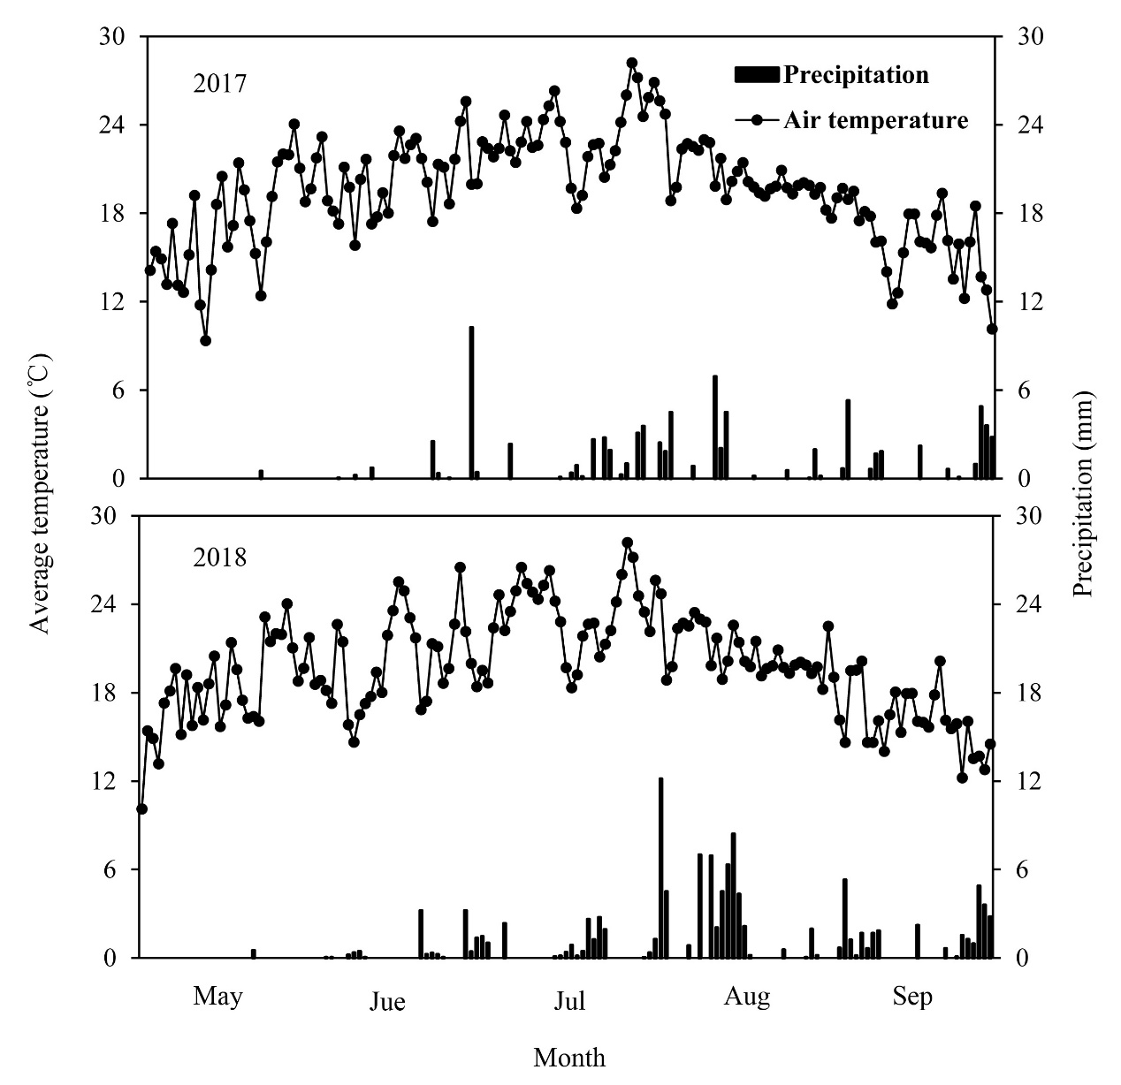Fig. S1. Monthly rainfall and average temperature from May to September in the growing seasons of 2017 and 2018. Top panel shows data from the 2017 growing season, while the bottom panel shows data from the 2018 growing season. Data were collected by the agricultural meteorological station located approximately 500 m from the study field.
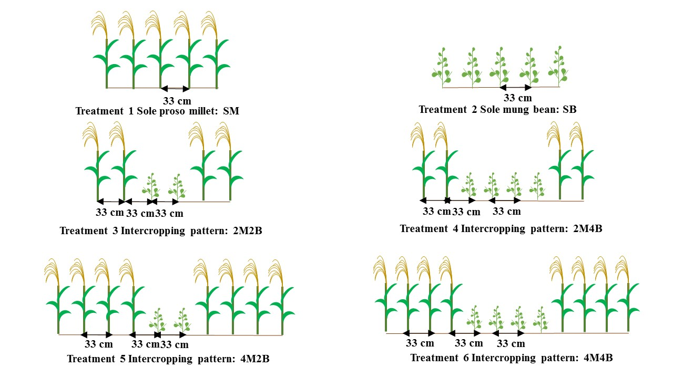
Fig. S2. Schematic illustration of row placement of proso millet and mung bean in different experimental planting patterns. Treatment 1 is a sole proso millet crop (SM). Treatment 2 is a sole mung bean crop (SB). Treatment 3 is two rows of proso millet alternated with two rows of mung bean (2M2B). Treatment 4 is two rows of proso millet alternated with four rows of mung bean (2M4B). Treatment 5 is four rows of proso millet alternated with two rows of mung bean (4M2B), and treatment 6 is four rows of proso millet alternated with four rows of mung bean (4M4B).

