Table 1S. Results of ANOVA test (mean of squares) for the effect of different treatments (0, 5, 7.5 and
10 mM SiK®) on the chestnut plants exposed to 25°C, heat stress of 32°C and recovery at 25°C relatively to the gas exchange parameters: net photosynthetic rate (P_{N}), transpiration rate (E), stomatal conductance (g_{s}), and water use efficiency (WUE) (n = 12). *** – P≤0.001, ** – P≤0.01, * – P≤0.05, ns – nonsignificant, according to ANOVA test.

 | P_{N} |  | E |  | g_{s} |  | WUE
Variation factor | (P) | Var (%) | (P) | Var (%) | (P) | Var (%) | (P) | Var (%)
Treat. | *** | 45.9 | *** | 50.2 | * | 28.1 | *** | 56.4
Temp. | *** | 28.0 | n.s. | 20.1 | ** | 10.9 | n.s. | 10.3
Treat. × Temp. | *** | 16.6 | ** | 13.3 | *** | 17.3 | *** | 22.0
Residual |  | 13.9 |  | 25.3 |  | 27.6 |  | 19.6

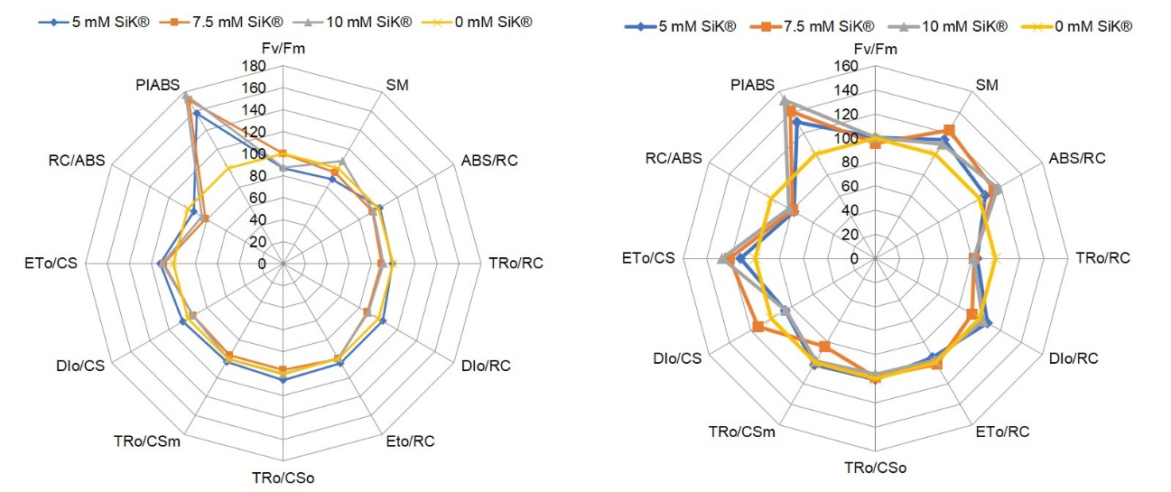

Fig. 1S. A ‘spider plot’ of selected parameters characterizing behavior of PSII of chestnut plants fertilized with 0, 5, 7.5, and 10 mM SiK® exposed to heat stress of 32°C (left) and recovery at 25°C (right). All values are shown as percent of control (control plants = 100%). F_{v}/F_{m} (maximum efficiency of PSII photochemistry), SM (energy necessary for the closure of all reaction centers), ABS/RC (light absorption flux (for PSII antenna chlorophylls) per reaction center, TR₀/RC (trapped (maximum) energy flux initial (leading to Q_{A} reduction) per reaction center), DI₀/RC (dissipation energy flux initial per PSII reaction center), ET₀/RC (maximum electron transport flux initial (further than Q_{A}⁻) per PSII reaction center), TR₀/CS₀ (trapping at time zero, per CS), TR₀/CS_{m} (trapped (maximum) energy flux (leading to Q_{A} reduction) per CS), DI₀/CS (dissipation at time zero, per CS), ET₀/CS (electron transport at time zero, per CS), RC/ABS (light absorption flux (density of reaction centers per PSII antenna chlorophyll)), and PI_{ABS} (the performance index).

