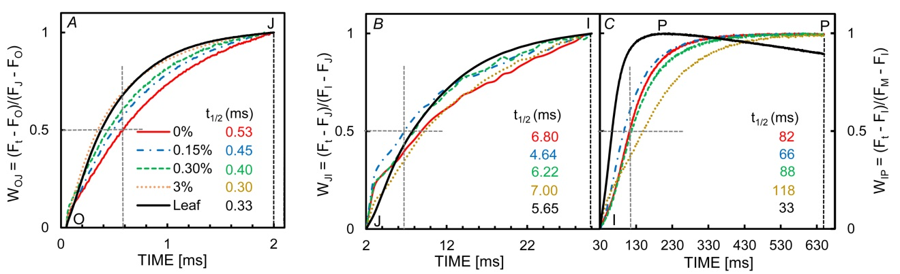
Fig. 1S. Graphs used to evaluate the half-time (t_{½}) of the fluorescence rise during the O-J (A), J-I (B), and I-P (C) phases with the mean Chl fluorescence induction curves of five replicates for blue grama grass (leaf) and isolated cells in suspension in culture medium with different sucrose concentrations.

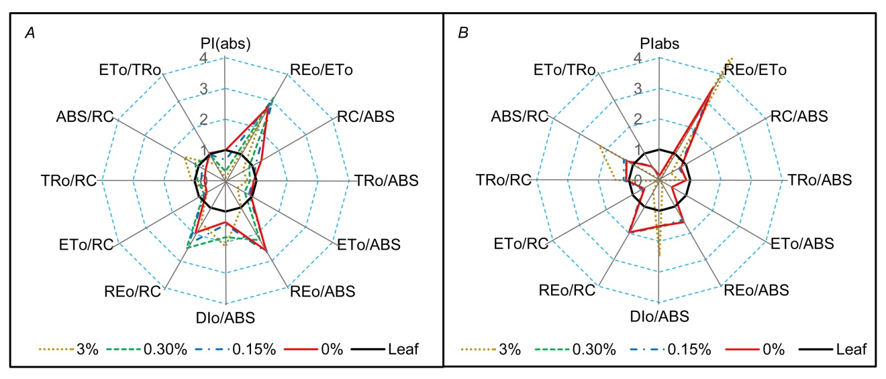

Fig. 2S. Radar plots of a set of relative JIP-test parameters for isolated cells of blue grama grass in suspension in culture medium with different sucrose concentrations (A), or for isolated cells deposited on filter paper (B), with the blue grama grass (leaf) as control. The parameters are the mean of five replicates.

