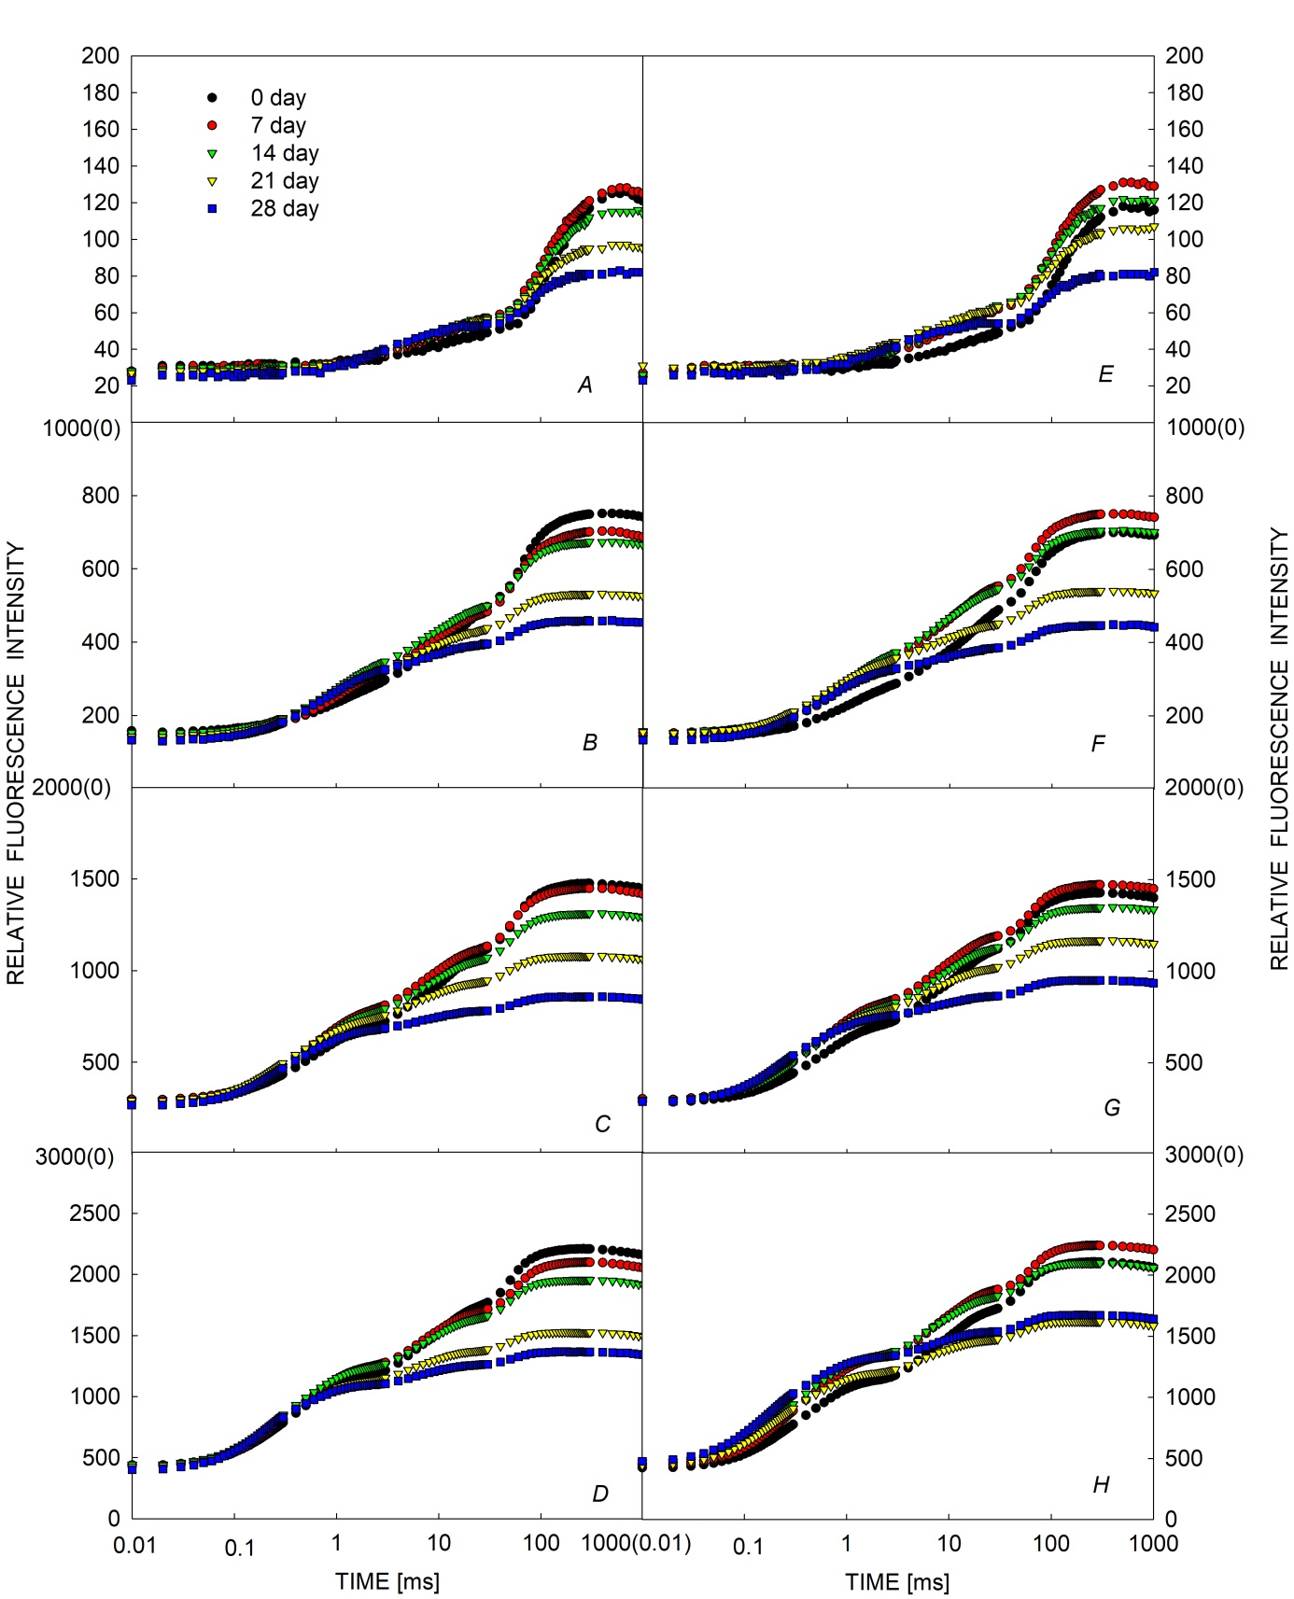
Fig. 1S. Changes in chlorophyll a fluorescence transient (CFI) of leaf adaxial and abaxial sides during leaf senescence in maize seedlings. Day 0: On the day of full leaf expansion; Day 7: On the 7th day after leaf full expansion; Day 14: On the 14th day after leaf full expansion; Day 21: On the 21st day after leaf full expansion; Day 28: On the 28th day after leaf full expansion. The pulse light intensities from up to bottom were 200 (A,E) and 1,000 (B,F) and 2,000 (C,G) and 3,000 (D,H) μmol m^{–2} s^{–1}. The chlorophyll a fluorescence transients were measured at adaxial (left) and abaxial (right) sides, respectively.

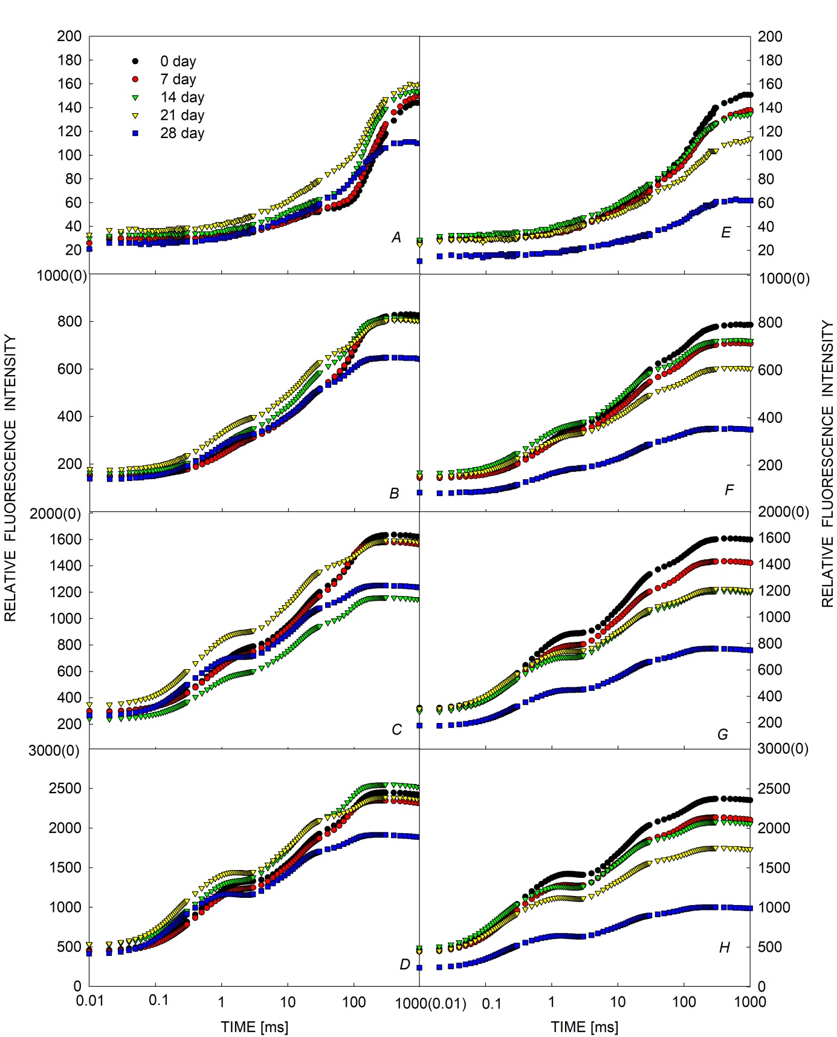
Fig. 2S. Changes in chlorophyll a fluorescence transient (CFI) of leaf adaxial and abaxial sides during leaf senescence in cucumber seedlings. Day 0: On the day of full leaf expansion; Day 7: On the 7th day after leaf full expansion; Day 14: On the 14th day after leaf full expansion; Day 21: On the 21st day after leaf full expansion; Day 28: On the 28th day after leaf full expansion. The pulse light intensities from up to bottom were 200 (A,E) and 1,000 (B,F) and 2,000 (C,G) and 3,000 (D,H) μmol m^{–2} s^{–1}. The chlorophyll a fluorescence transients were measured at adaxial (left) and abaxial (right) sides, respectively.

