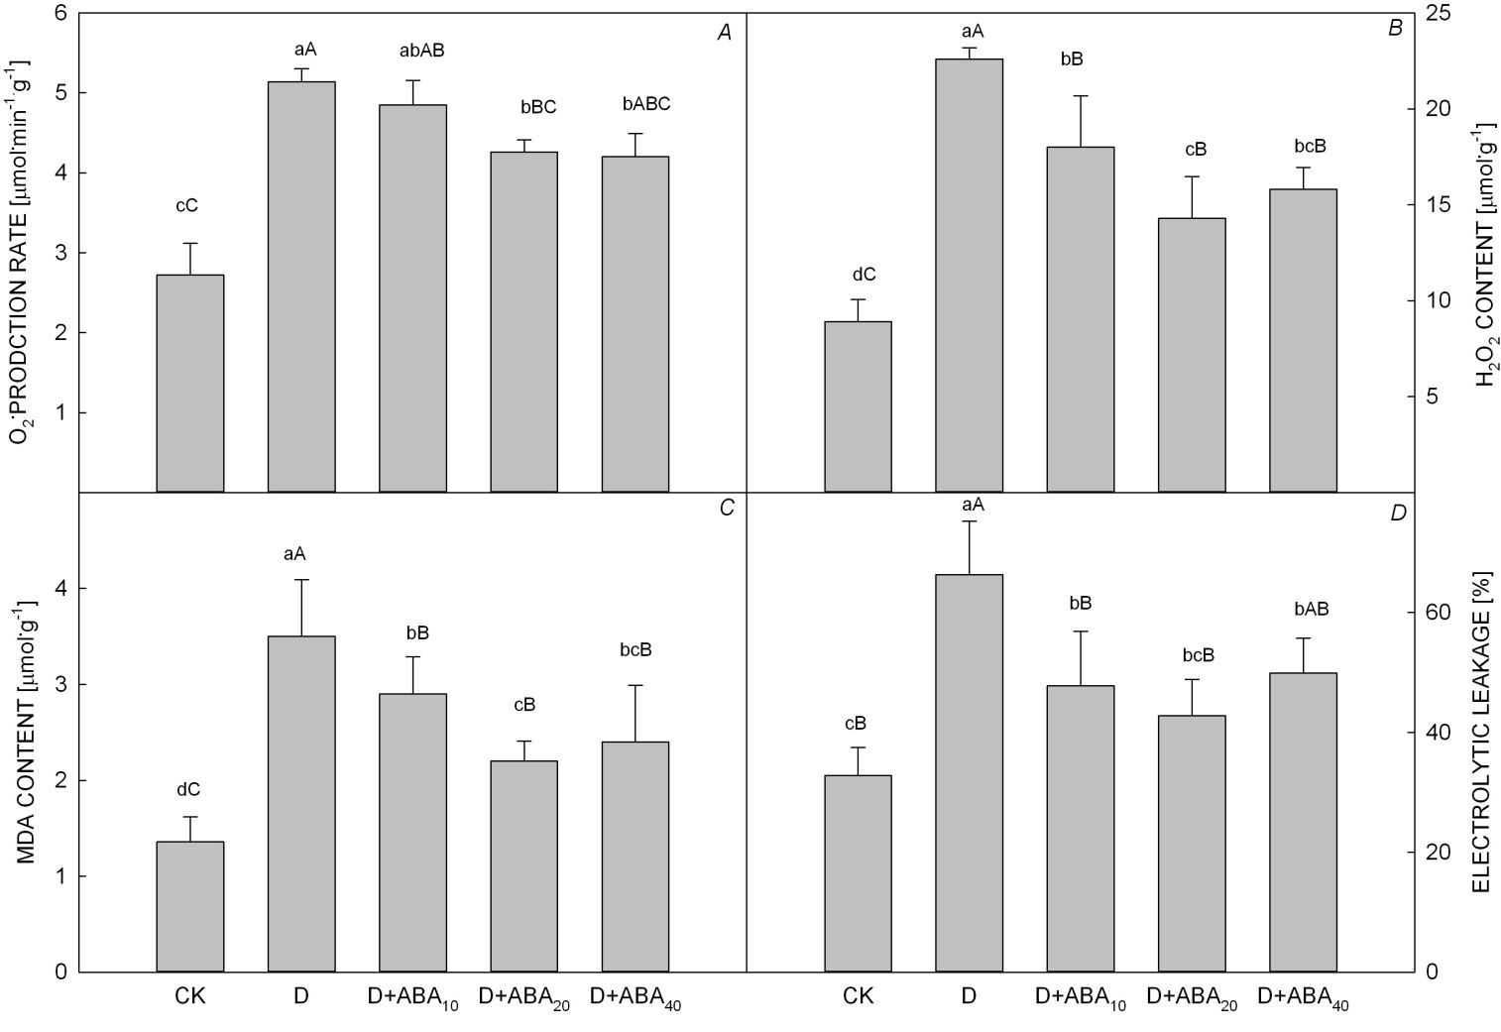

Fig. 1S. Effects of exogenous ABA at different concentrations on the rate of O₂•– production (A), H₂O₂ content (B), MDA content (C), and electrolyte leakage rate (D) of tobacco seedling leaves under drought stress. Significant differences were expressed by different small letters (P<0.05), and very significant differences were expressed by different capital letters (P<0.01). CK is the non-drought control. D is the drought treatment. D+ABA₁₀, D+ABA₂₀, and D+ABA₄₀ indicate 10, 20, and 40 μmol·L^{–1}ABA treatments under drought stress, respectively. Values are means ± SE (n = 3).

