Table 1S. Components for preparing the control and P-def solutions; developed based on the Hoagland solution (Hoagland and Arnon 1950); for details on iron chelate and micronutrients solutions see Table 2S.

No. | Component | Molar mass [g mol^{–1}] | Molar concentration  of a stock solution [M] | Amount of the stock solution  (in mL) required to prepare  1L of the nutrient solution
 | Control solution
1 | Ca(NO₃)₂ • 4H₂O | 236.15 | 1.0 | 4.0
2 | K₂SO₄ | 174.26 | 0.5 | 2.0
3 | KCl | 74.55 | 1.0 | 1.0
4 | KNO₃ | 101.10 | 1.0 | 3.5
5 | MgSO₄ • 7H₂O | 246.47 | 1.0 | 2.0
6 | NaH₂PO₄ | 119.98 | 0.5 | 2.0
7 | Iron chelate | - | - | 2.0
8 | Micronutrient solution | - | - | 1.0
 | Phosphorus-deficient solution
1 | Ca(NO₃)₂ • 4H₂O | 236.15 | 1.0 | 4.0
2 | K₂SO₄ | 174.26 | 0.5 | 1.0
3 | KCl | 74.55 | 1.0 | 1.0
4 | KNO₃ | 101.10 | 1.0 | 3.5
5 | MgSO₄• 7H₂O | 246.47 | 1.0 | 1.0
6 | CaCl₂ | 110.98 | 1.0 | 0.5
7 | Mg(NO₃)₂• 6H₂O | 256.41 | 1.0 | 1.0
8 | NH₄NO₃ | 80.05 | 1.0 | 1.0
9 | Iron chelate | - | - | 2.0
10 | Micronutrients | - | - | 1.0

Table 2S. Components for preparing iron chelate and micronutrient solutions.

No. | Iron chelate | Amount (g) for 1L of stock solution
1 | FeSO₄ | 9.000
2 | EDTA | 12.000
No. | Micronutrient solution | Amount (g) for 1L of stock solution
1 | CuSO₄ • 5H₂O | 0.400
2 | H₃BO₃ | 3.000
3 | MnSO₄ • 4H₂0 | 1.100
4 | Na₂MoO₄ • 2H₂O | 0.125
5 | ZnSO₄ • 7H₂O | 0.280

Table 3S. Concentration of selected elements: N (in %), P (in g kg^{–1}), K (in g kg^{–1}), Mg (in g kg^{–1}), S (in g kg^{–1}) and Fe (in mg kg^{–1}) in the foliage of the control sample (CS) and P-deficient (P-def) plants of two cultivars: ‘Fluo HF1’ (A) and ‘Suntella F1’ (B). Each value represents the analysis result for the foliage of the sample pooled from 3–27 plants.

A
Element | Treatment | DAT
Element | Treatment | 3 | 6 | 12 | 19 | 25
N [%] | CS | 6.56 | 5.95 | 5.74 | 6.05 | 5.96
N [%] | P-def | 6.68 | 6.45 | 4.62 | 5.45 | 5.80
P [g kg^{–1}] | CS | 7.45 | 6.10 | 4.50 | 5.17 | 4.49
P [g kg^{–1}] | P-def | 4.07 | 2.43 | 0.97 | 8.06 | 6.97
K [g kg^{–1}] | CS | 40.23 | 29.13 | 20.61 | 28.99 | 35.90
K [g kg^{–1}] | P-def | 17.54 | 37.93 | 25.32 | 28.46 | 31.09
Mg [g kg^{–1}] | CS | 3.94 | 4.77 | 5.27 | 5.46 | 5.13
Mg [g kg^{–1}] | P-def | 3.19 | 3.62 | 2.85 | 4.55 | 6.71
S [g kg^{–1}] | CS | 6.91 | 7.24 | 10.20 | 11.97 | 13.94
S [g kg^{–1}] | P-def | 6.22 | 6.69 | 6.07 | 10.26 | 12.82
Fe [mg kg^{–1}] | CS | 82.40 | 69.20 | 83.60 | 79.80 | 77.80
Fe [mg kg^{–1}] | P-def | 76.90 | 87.40 | 63.40 | 87.00 | 99.30
B
N [%] | CS | 7.14 | 6.85 | 7.02 | 6.93 | 6.53
N [%] | P-def | 7.18 | 6.78 | 5.97 | 6.83 | 6.46
P [g kg^{–1}] | CS | 6.07 | 5.48 | 4.88 | 4.27 | 3.72
P [g kg^{–1}] | P-def | 3.52 | 2.37 | 1.05 | 17.45 | 10.17
K [g kg^{–1}] | CS | 29.71 | 30.03 | 14.74 | 28.21 | 26.15
K [g kg^{–1}] | P-def | 41.61 | 32.20 | 31.23 | 27.26 | 31.63
Mg [g kg^{–1}] | CS | 4.52 | 5.22 | 5.52 | 5.85 | 5.16
Mg [g kg^{–1}] | P-def | 3.68 | 4.16 | 4.22 | 4.53 | 5.86
S [g kg^{–1}] | CS | 5.79 | 6.66 | 7.10 | 7.83 | 7.23
S [g kg^{–1}] | P-def | 6.48 | 6.98 | 6.26 | 9.13 | 8.81
Fe [mg kg^{–1}] | CS | 81.70 | 85.40 | 76.00 | 89.70 | 71.80
Fe [mg kg^{–1}] | P-def | 198.80 | 102.80 | 103.10 | 82.80 | 99.20

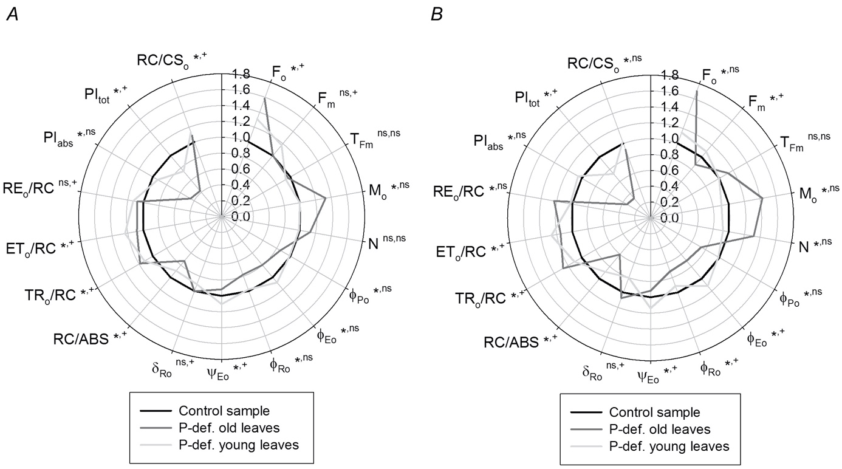

Fig. 1S. The values of the JIP-test parameters calculated for Raphanus sativus L. var. sativus cultivars ‘Fluo HF1’ (A) and ‘Suntella F1’ (B) presented by means of the ratio: phosphorus deficient old and young leaves vs. the control sample, on 13th d after treatment (DAT). Mean values were derived from 15–37 measurements per treatment. Asterisks indicate the significance of differences according to the All Pairwise Multiple Comparison Procedures (Holm-Sidak method) with an overall significance level = 0.05 (* for old leaves; ⁺ for young leaves); ^{ns} – no significant difference.

