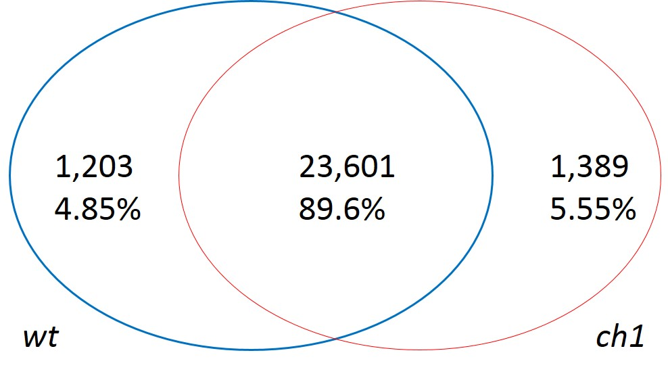

Fig. 1S. Comparison of gene expression in wildtype (wt) and chlorophyll b-lacking (ch1) rices.

Table 1S. Primer sequences used in this study. *Reference gene.

Marker | Forward sequence (5’-3’) | Reverse sequence (5’-3’)
GLuRS | GCTCTCCGCTCAAGTGAATACC | GATCAGTCCAGTCCTCCACCTT
ALAD | GGCATGGGCTTCTTGATGAGG | CCAGAGCAACATCCGTGTAGAC
PBGD | GAAGGATTGACATTGCCGTCCA | GTCTACGCAGAGAAGCACTTCC
UROD | GACGGCGTCATCCTGTTCTC | TGCGTAGAATCTTGAGCGACTC
CPOX | AAGCACCGTAATGAGCGTCG | TCAGTTGTTGCCATGCCTTGT
POR | TCATCCTCGGCTCCATCACC | CTCCTGCATCGTCAGCATGTT
DVR | CAGGTTCATCAAGGTGCCGAT | CGTCATCTCGTCGCTGTACTC
CAO | GCATGGACTTCTGCTGGACAA | AGATGCCAGTGGTTGACAAGAC
HCBR | GCAGGAAGCAAGACATGGATGA | GCATTGGAGCAAGCCTGTCA
CHLG | GGGCACTGTTGTTAGCAGGG | GCCAATGTAGCTCGCACCAA
NOL | CACTGCTTCTCCTGGAATGGTC | GCAAGATCCTTGGTGGTGTCAA
MgCH | AAGATGGTTGCCGAACTGGATG | ATGTCCTGGAGCTGCTTCTCA
UBQ10* | CTCATCTCCTCTCCTCGCATCA | CCACCAATCGGATCTAGCAACA

Table 2S. Summary of genome mapping. *Uniquely mapping ratio: The percentage of reads that map to only one location of the reference genome. ch1 – chlorophyll b-lacking mutant; wt – wildtype.

Sample | Total clean reads | Total mapping ratio [%] | Uniquely mapping ratio [%]*
ch1 | 28,928,599 | 97.94 | 89.85
wt | 25,306,787 | 96.84 | 89.16

Table 3S. Summary of gene mapping ratio. *Uniquely mapping ratio: The percentage of uniquely mapped reads. ch1 – chlorophyll b-lacking mutant; wt – wildtype.

Sample | Total clean reads | Total mapping ratio [%] | Uniquely mapping ratio [%]*
ch1 | 28,928,599 | 93.01 | 80.91
wt | 25,306,787 | 88.93 | 79.56

