Supplementary material
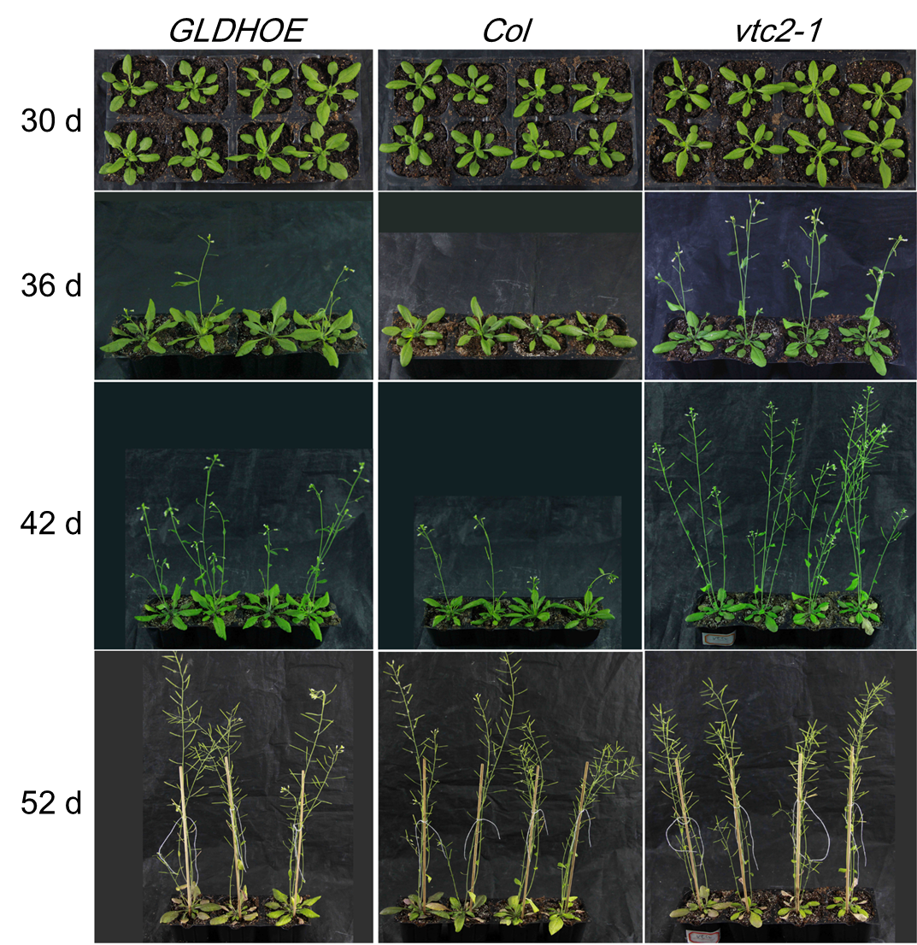

Fig. 1S. Phenotypes of GLDHOE, Col, and vtc2-1 under normal conditions. GLDHOE, Col, and vtc2-1 are shown from left to right, respectively. The appearances of plants grown on 30th day, 36th day, 42nd day and 52nd day were shown from top to bottom, respectively.

