Table 1S. Analysis of variance of main effects (light and water) and their interactions on photosynthetic characteristics and cuticlar wax compositions of faba bean leaves. “*” represent significant at P<0.05, “**” represent significant at P<0.01, “***” represent significant at P<0.001.

 | Light (L) | Water (W) | L×W
Net photosynthetic rate | 99.42*** | 177.94*** | 31.31***
Stomatal conductance | 28.84*** | 32.22*** | 4.87**
Transpiration rate | 47.73*** | 155.04*** | 12.86***
Intercellular CO₂ concentration | 22.62*** | 66.25*** | 7.31***
Total wax | 25.66*** | 6.82* | 8.97***
Fatty acids | 48.27*** | 0.78ns | 15.61***
Primary alcohols | 42.32*** | 26.67*** | 10.01***
Alkanes | 11.11*** | 13.75** | 6.31**
Alkylresorcinols | 93.07*** | 6.31* | 9.09***
Unidentified | 56.43*** | 25.76*** | 4.56**

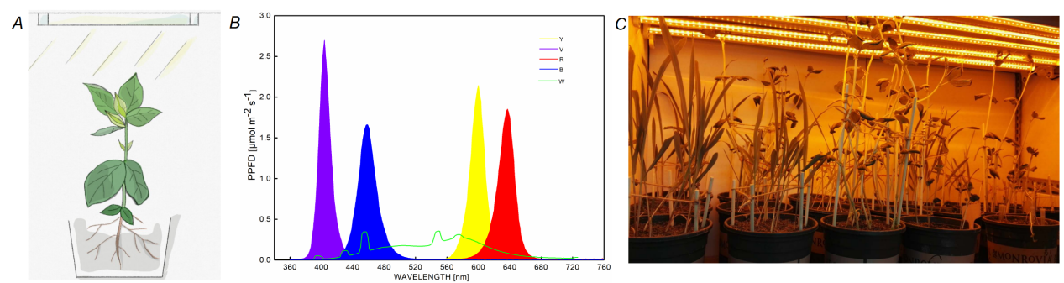
Fig. 1S. Plant growth condition and LED light spectra irradiance. Plant grows under LED lightning (A); spectral irradiance of different light sources used in this study (B); plants grow under yellow light (C).

Fig. 2S. Effects of drought stress on fatty acids chain length distribution of faba bean leaves under different light wavelengths. W, R, Y, B and V represent white, red, yellow, blue and violet light, respectively. Each data were the mean of four replications. The error bar represents standard error. “*” represent significance at P<0.05, “**” represent significance at P<0.01, “***” represent significance at P<0.001.

Fig. 3S. Effects of drought stress on primary alcohol chain length distribution of faba bean leaves under different light wavelengths. W, R, Y, B and V represent white, red, yellow, blue and violet light, respectively. Each data were the mean of four replications. The error bar represents standard error. “*” represent significance at P<0.05, “**” represent significance at P<0.01, “***” represent significance at P<0.001.

Fig. 4S. Effects of drought stress on alkanes chain length distribution of faba bean leaves under different light wavelengths. W, R, Y, B and V represent white, red, yellow, blue and violet light, respectively. Each data were the mean of four replications. The error bar represents standard error. “*” represent significance at P<0.05, “**” represent significance at P<0.01, “***” represent significance at P<0.001.

