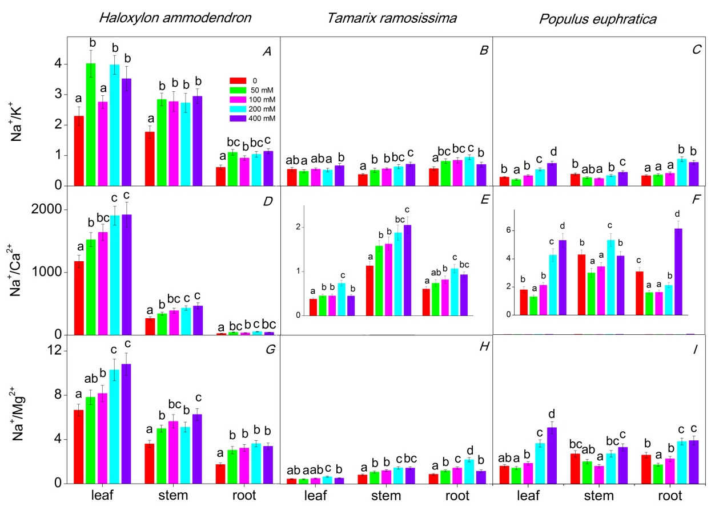

Fig. 1S. Effects of NaCl exposure (0, 50, 100, 200, and 400 mM) on Na⁺/K⁺ (A–C), Na⁺/Ca²⁺ (D–F), and Na⁺/Mg²⁺ (G–I) ratios in leaves, stems, and roots of Haloxylon ammodendron, Tamarix ramosissima, and Populus euphratica. Values are means ± SD (n = 4). Different lowercase letters indicate significant differences of Na⁺/K⁺, Na⁺/Ca²⁺, and Na⁺/Mg²⁺ ratios in the same organ across the range of NaCl concentrations at p<0.05 according to Fisher's LSD test.

