Supplement

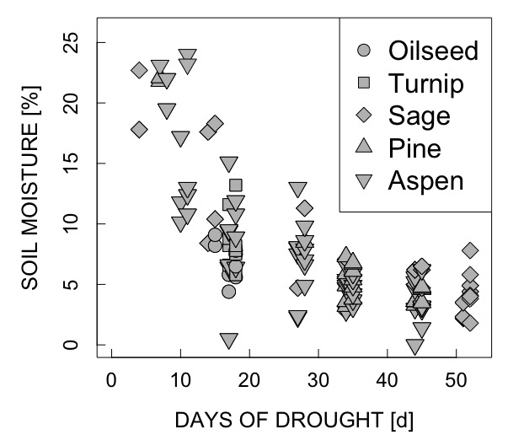

Fig. 1S. Soil moisture decrease across species under progressive drought.

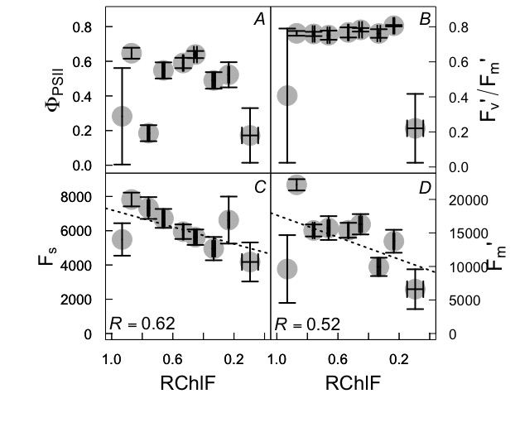

Fig. 2S. Comparison of computed RChlF (Eq. 1) from the FluoCAM images (pre-pulse) and in vivo ChlF-related traits from the MultispeQ. Ф_{PSII} – the effective quantum yield of PSII photochemistry (A), F_{v}'/F_{m}' – theoretical efficiency of PSII in the light-adapted state (B), F_{s} – the steady-state fluorescence yield (C) and F_{m}' as the maximal fluorescence yield of the light-adapted state (D) are represented. Gray dots are the average values across all species (oilseed, turnip, aspen, sage, and pine) over 52 d of progressive drought with the error bars representing SE. Dotted lines represent the correlation between RChlF and F_{s} (C) or F_{m}' (D). R values are results of Pearson's correlation test.

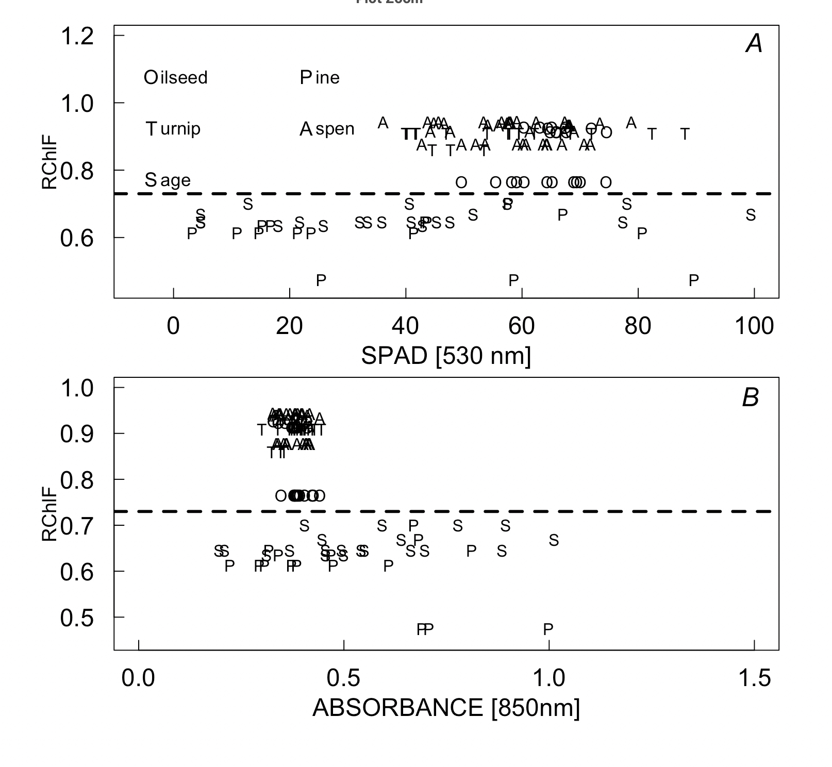

Fig. 3S. Variation of computed RChlF (Eq. 1) from the FluoCAM images (post-pulse) with MultispeQ traits across species at full watering. Single measurement for oilseed, turnip, aspen, sage, and pine are denoted by capital letters: O, T, A, S and P, respectively. Variation with SPAD at 530 nm (A) and absorbance at 850 nm (B) are reported. Dotted lines represent the separation of the species into two groups based on the range of RChlF recorded for well-watered leaves or needles.

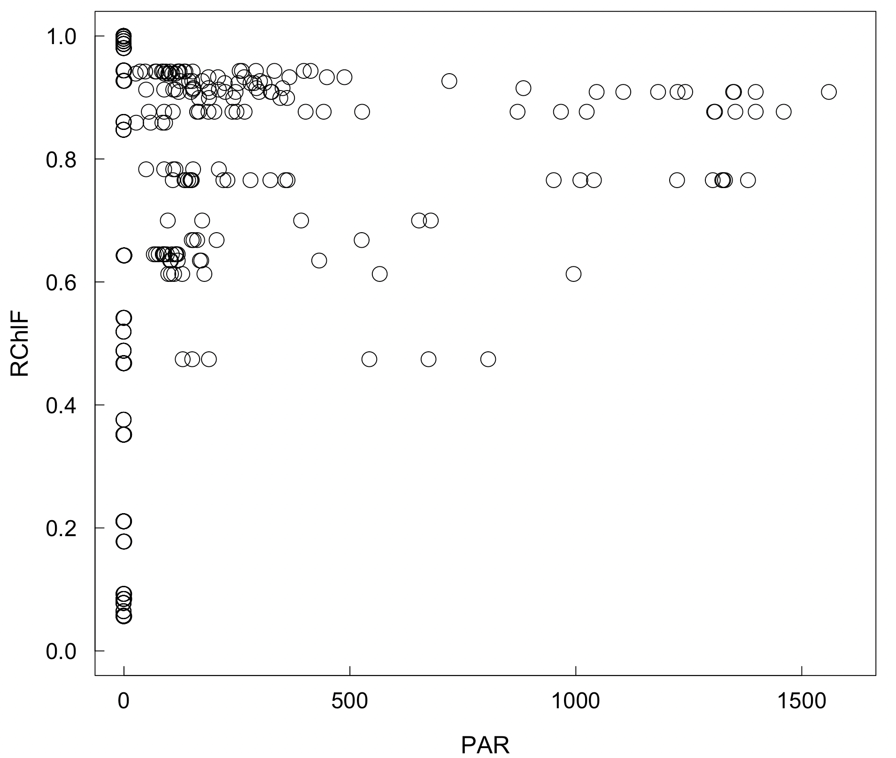

Fig. 4S. Variation of computed RChlF (Eq. 1) from the FluoCAM images (post-pulse) with light intensity as photosynthetic active radiation (PAR) from the MultispeQ across all species and all hydration conditions.

