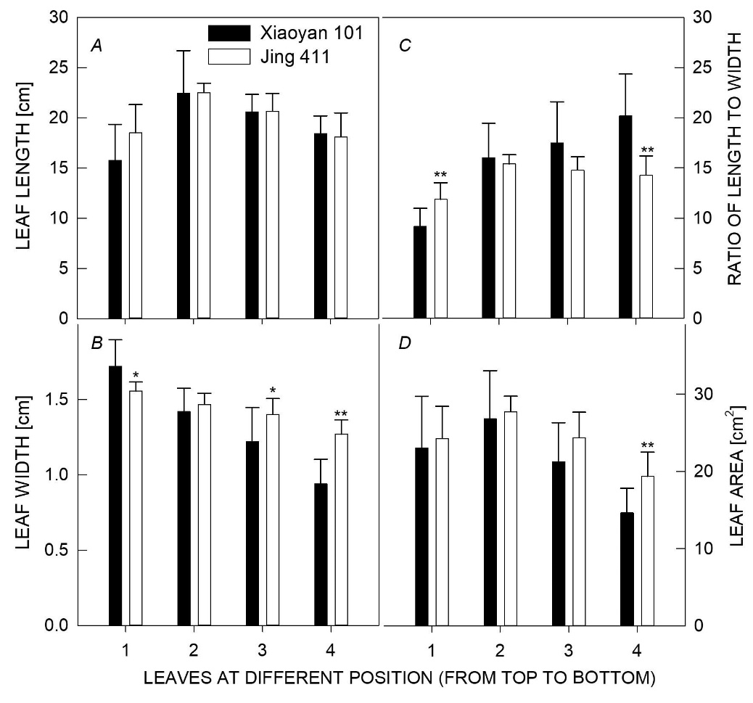

Fig. 1S. Leaf length (A), leaf width (B), ratio of leaf length to leaf width (C), and leaf area (D) in the top four leaves from the main culms of Xiaoyan 101 and Jing 411 at the grain-filling stage. * and ** denote significant difference at P<0.05 and P<0.01, respectively.

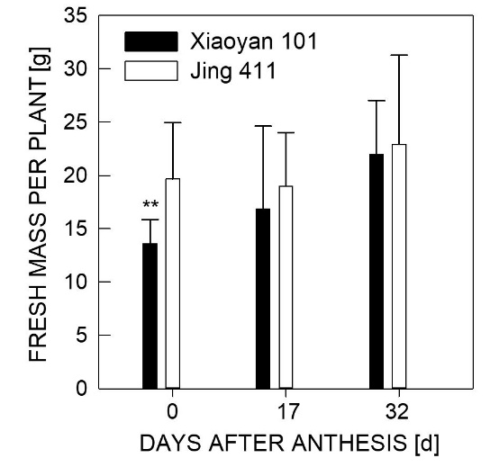

Fig. 2S. The fresh mass per plant at 0, 17, 32 d after anthesis in Xiaoyan 101 and Jing 411. ** denotes significant difference at P<0.01.

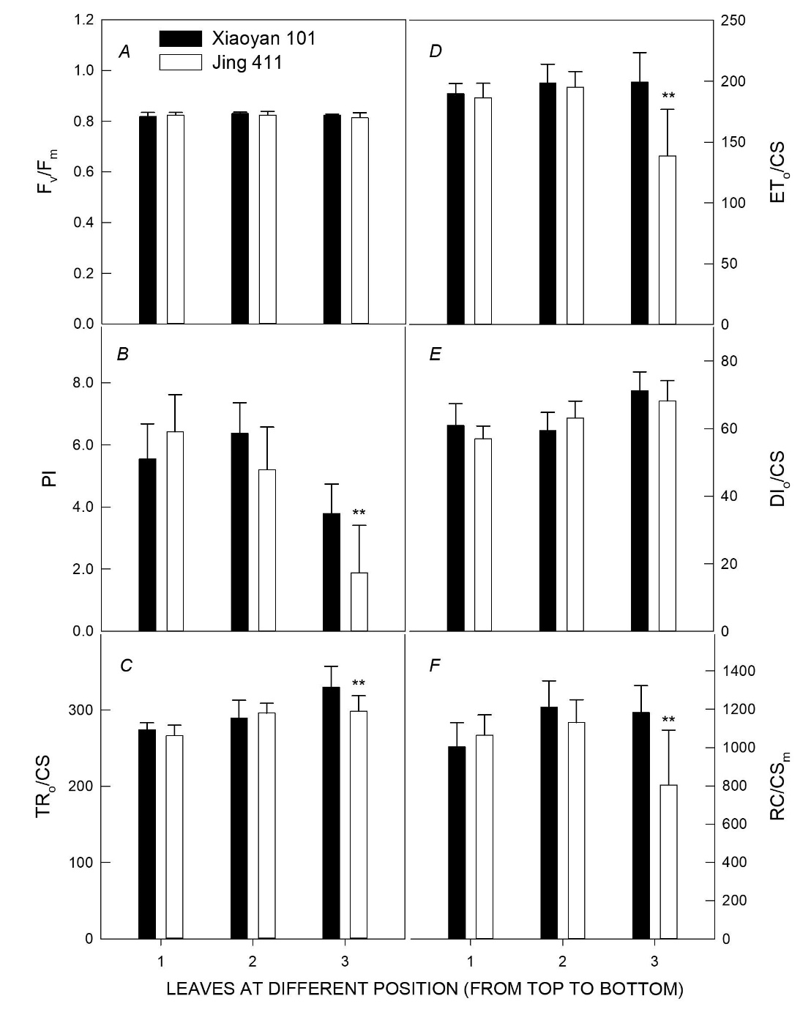

Fig. 3S. The chlorophyll a fluorescence parameters in the top three leaves in the canopy of Xiaoyan 101 and Jing 411 at 12 d after anthesis. Maximum photochemical efficiency of PSII (F_{v}/F_{m}) (A); performance index (PI) (B); trapped energy flux per cross-section (TR₀/CS) (C); electron transport flux per cross-section (ET₀/CS) (D); dissipated energy flux per cross-section (DI₀/CS) (E); density of reaction center per excited cross-section (RC/CS_{m}) (F). ** denote significant difference at P<0.05 and P<0.01, respectively.

