Supplementary figures

Fig. 1S. F_{v}/F_{m} of the control (green cells throughout) and the green-to-red transition (and recovery) experiment. Note that the decline of F_{v}/F_{m} to 0 is due to the large decrease in the Chl fluorescence signal overall and not necessarily due to the complete loss of the PSII activity of red cells.
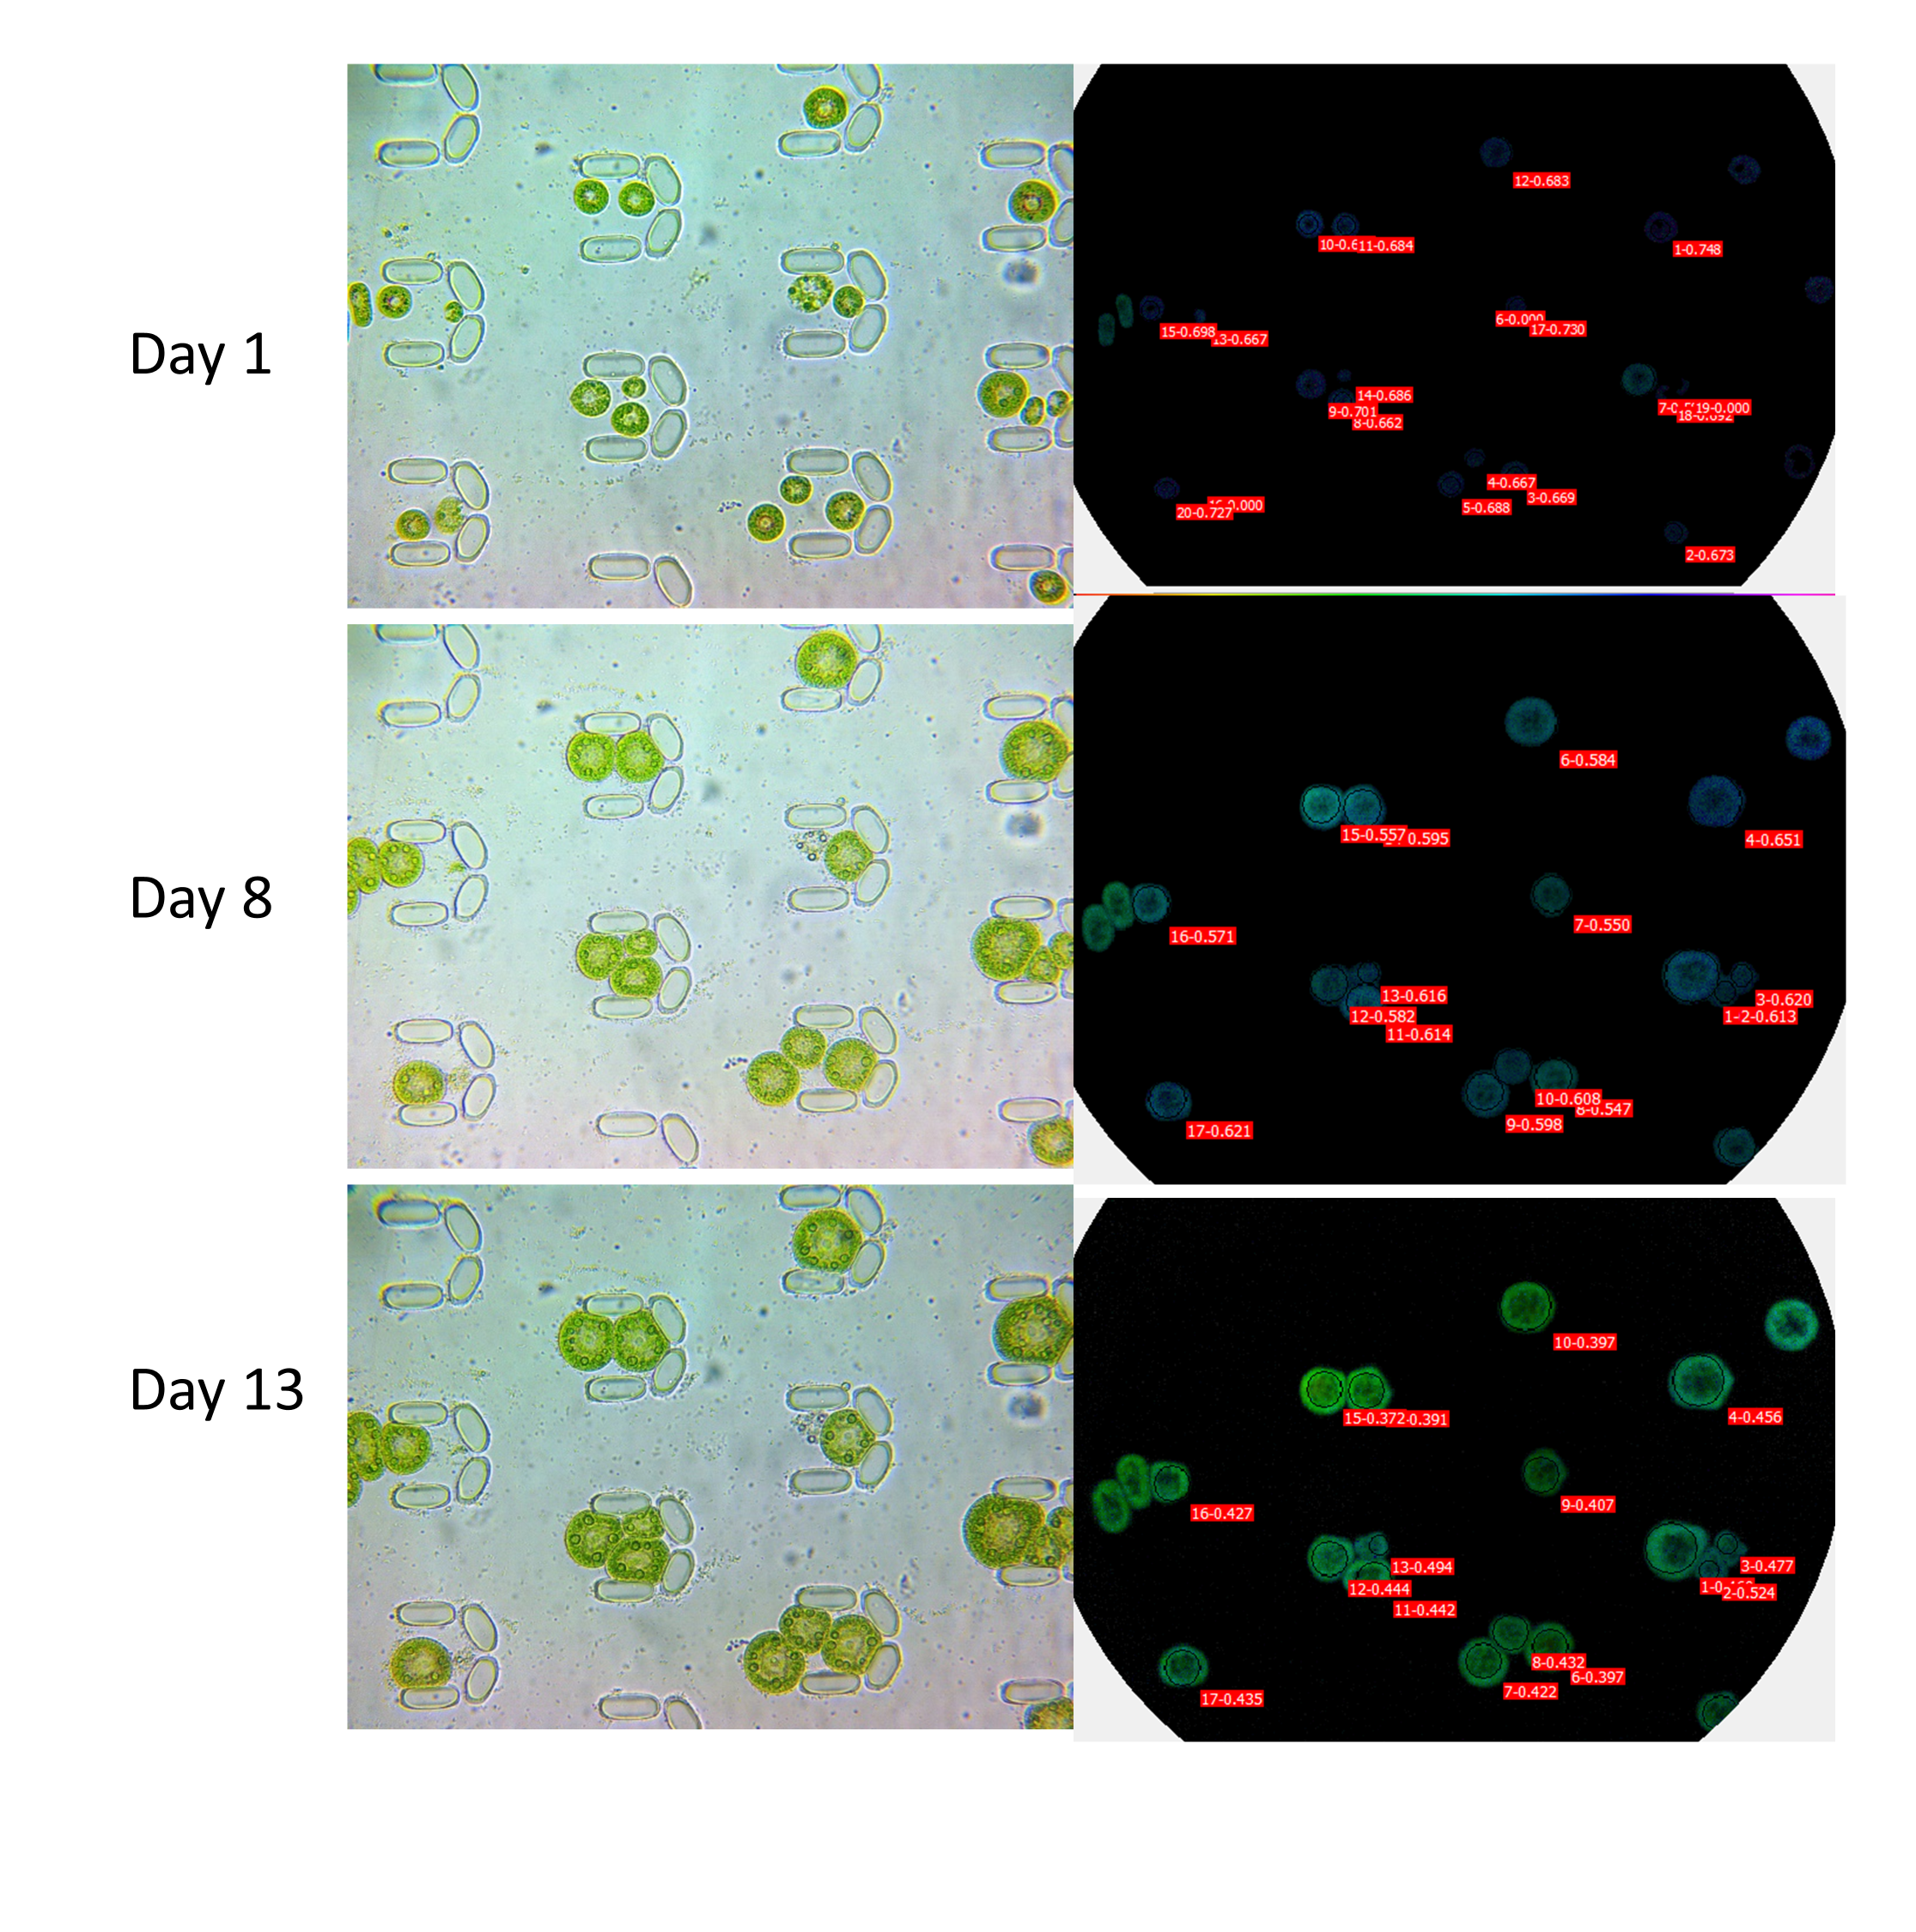
Fig. 2S. Microscopic and F_{v}/F_{m} images of cells that were kept in the green stage (in BG11) for the control experiment.

