Movie 1S. Time/spatial fluctuation in phycobilisomes fluorescence. The selected data (pictures) for the movie are shown in Fig. 2SA. For the online version of the movie, see the enclosed file or the link https://youtu.be/KTCJZSyA1E0.

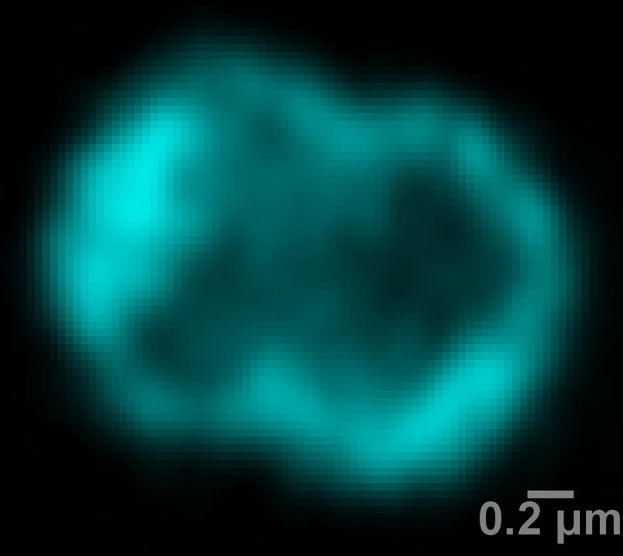
Movie 2S. Time/spatial fluctuations in chlorophyll a fluorescence from Photosystem II. The selected data for the movie are presented also in Fig. 2SB. For the online version of the movie, see the enclosed file or the link https://youtu.be/h5C8deKrkZc.

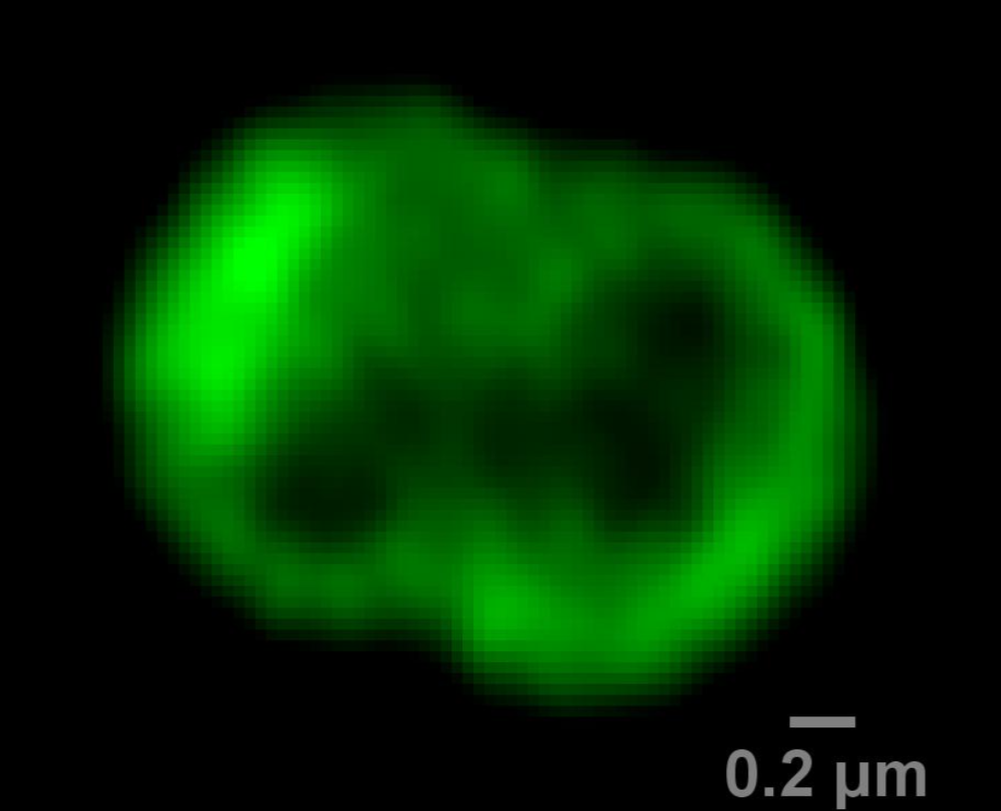

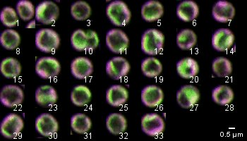

Fig. 1S. Synechocystis sp. PCC 6803 PSI-YFP cells imaged by the Airyscan detector. RGB picture (red-green-blue) combined from three detected channels of chlorophylls emission from PSII (red channel), YFP fluorescence from PSI (green) and phycobilisomes emission (blue) as described in Fig. 1. The most dominant colors, magenta and green, represent two main microdomain types: (1) grana-like visible as magenta (dominant PSII and PBS signal, less YFP-PSI emission); (2) stroma-like visible as green (dominant PSI and less PBS and PSII signal). Scale bar 0.5 µm.

Fig. 2S. The characteristic changes in the fluorescence signal of chlorophyll (PSII) and phycobilisomes inside of the single cells during time-lapse images. Images represent selected time-lapse pictures acquired 0.6 s after each other. The zoomed parts show nanoscale dots of PBS and Chl fluorescence inside of the selected areas. The movement of the dots is visible in the enclosed Movie 1S and 2S.

Fig 3S. Time and spatial fluorescence fluctuation in the chlorophyll signal inside of thylakoid membranes areas of Synechocystis sp. PCC 6803. Chlorophyll fluorescence from thylakoids was detected every 0.60 s by Airyscan detector (pixel size ~ 33 × 33 nm, excitation: 488 nm, detection: LP 685 nm). (A) Approximate positions of the selected areas in the picture of chlorophyll fluorescence (Area 1 and Area 2). The yellow arrows indicate proposed PSII trafficking (Chl fluorescence) in 2D approximation. (B) Calculated fluorescence fluctuation in the selected thylakoid membrane compartments – Area 1 and Area 2. The insert represents position of the calculated areas: Area 1 consists of the small rectangle areas marked as 10, 11, 12, and 13; Area 2 consists of the small rectangle areas marked as 6, 7, 8, and 9. Data represent averaged behavior of fluorescence signal in the selected membrane area of one representative cell.

