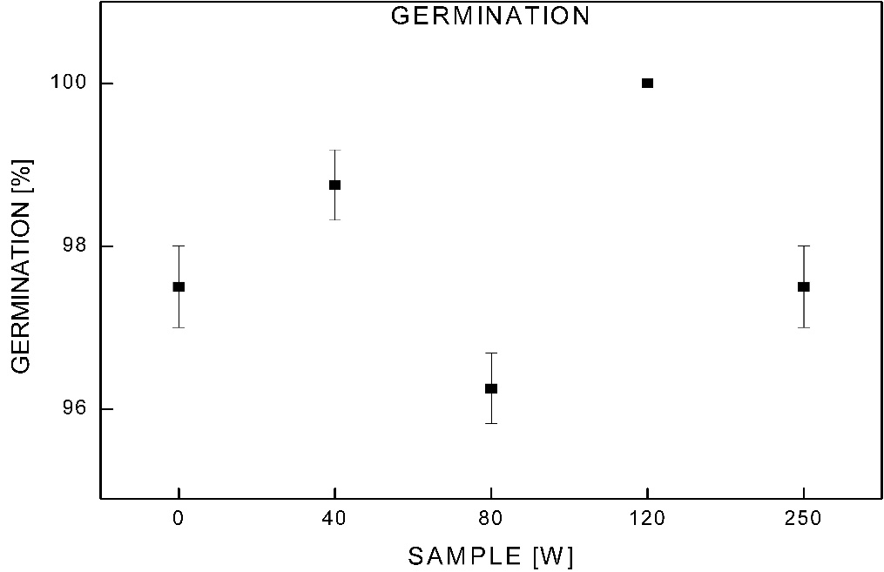

Fig. 1S. Germination rate of millet seeds. Values are the arithmetic mean ± SD. The significance was determined against untreated samples (0 W), n = 5.

