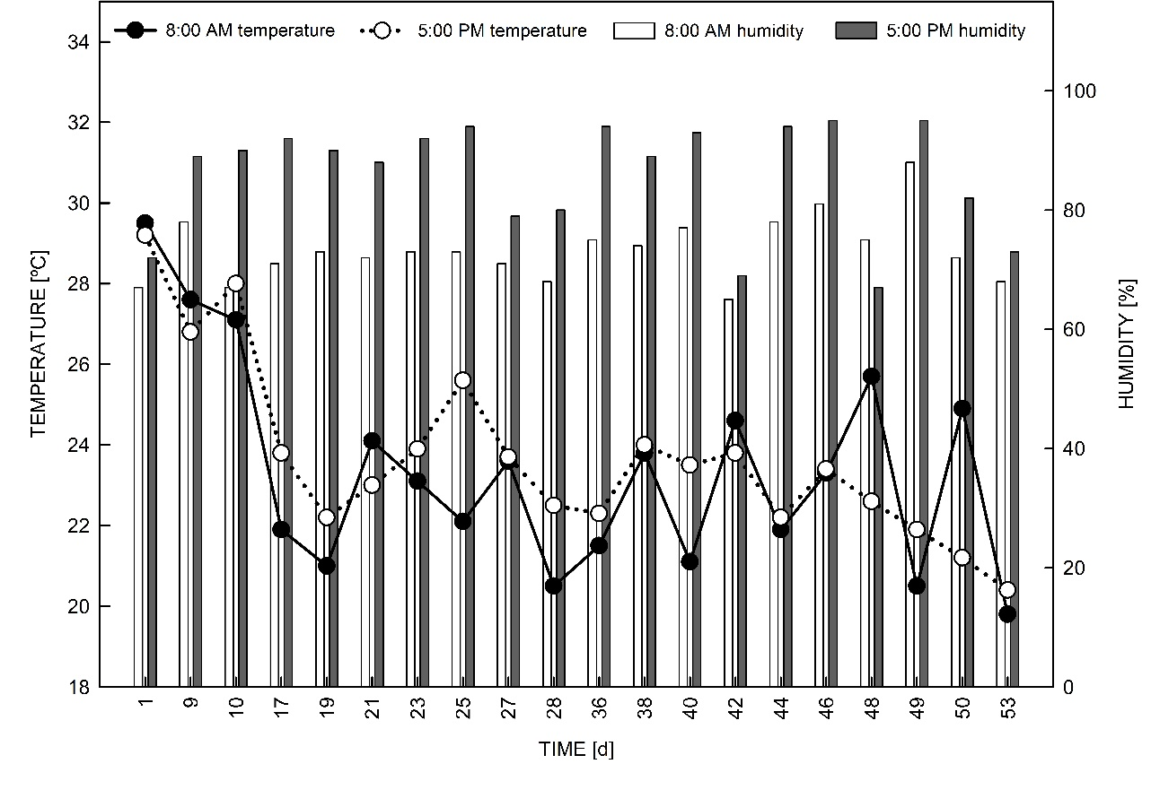
Fig. 1S. Average temperature [°C] and relative air humidity [%] inside the greenhouse during the three cycles of water deficit and recovery. Days 9, 27, and 49 represent the final dehydration phase. Days 17 and 36 correspond to the beginning of the dehydration phase of the second and third water deficit cycles, respectively. Day 49 corresponds to the end of the dehydration phase of the third water deficit cycle. Day 50 represents the beginning of the rehydration phase, and 53 days mark the end of the rehydration phase of the third cycle.

