Table 1S. The maximum stomatal conductance (G_{s-max}, [mmol m^{–2} s^{–1}]) of three rice varieties.

Parameters Cultivars | JR3015 | Wufengyou3015 | Jifengyou3015
maximum stomatal conductance  (G_{s-max}, [mmol m^{–2} s^{–1} ]) | 0.198 ± 0.007^{b} | 0.512 ± 0.009ª | 0.492 ± 0.012ª

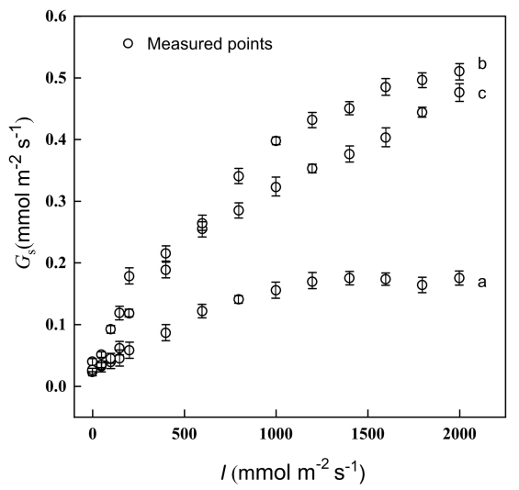

Fig. 1S. Light-response curves of stomatal conductance for three rice species (a – JR3015; b – Wufengyou3015; and c – Jifengyou3015). Values are means ± standard errors (n = 3). G_{s} – stomatal conductance; I – light intensity.

