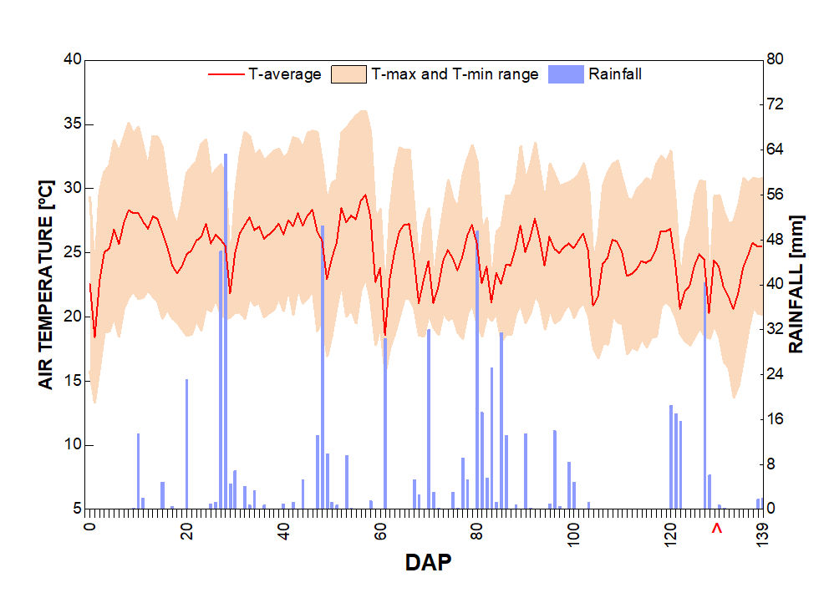

Fig. 1S. Daily rainfall, average air temperature, and maximum and minimum range of air temperature. The arrow indicates the date of evaluation.

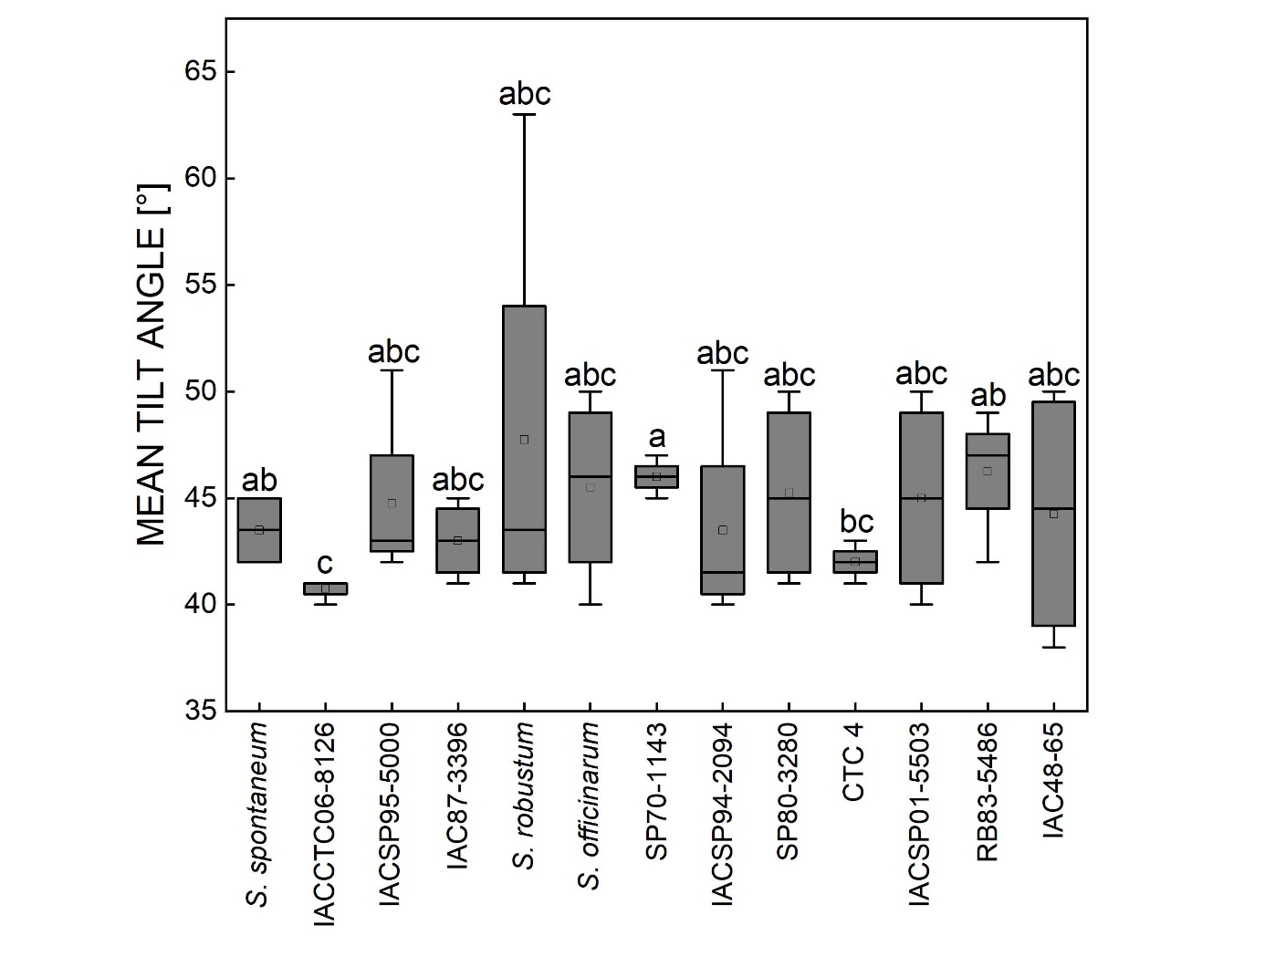

Fig. 2S. Mean tilt angle of the foliage of thirteen sugarcane genotypes. Different letters indicate statistical differences among genotypes (BF₁₀ > 3, n = 4).

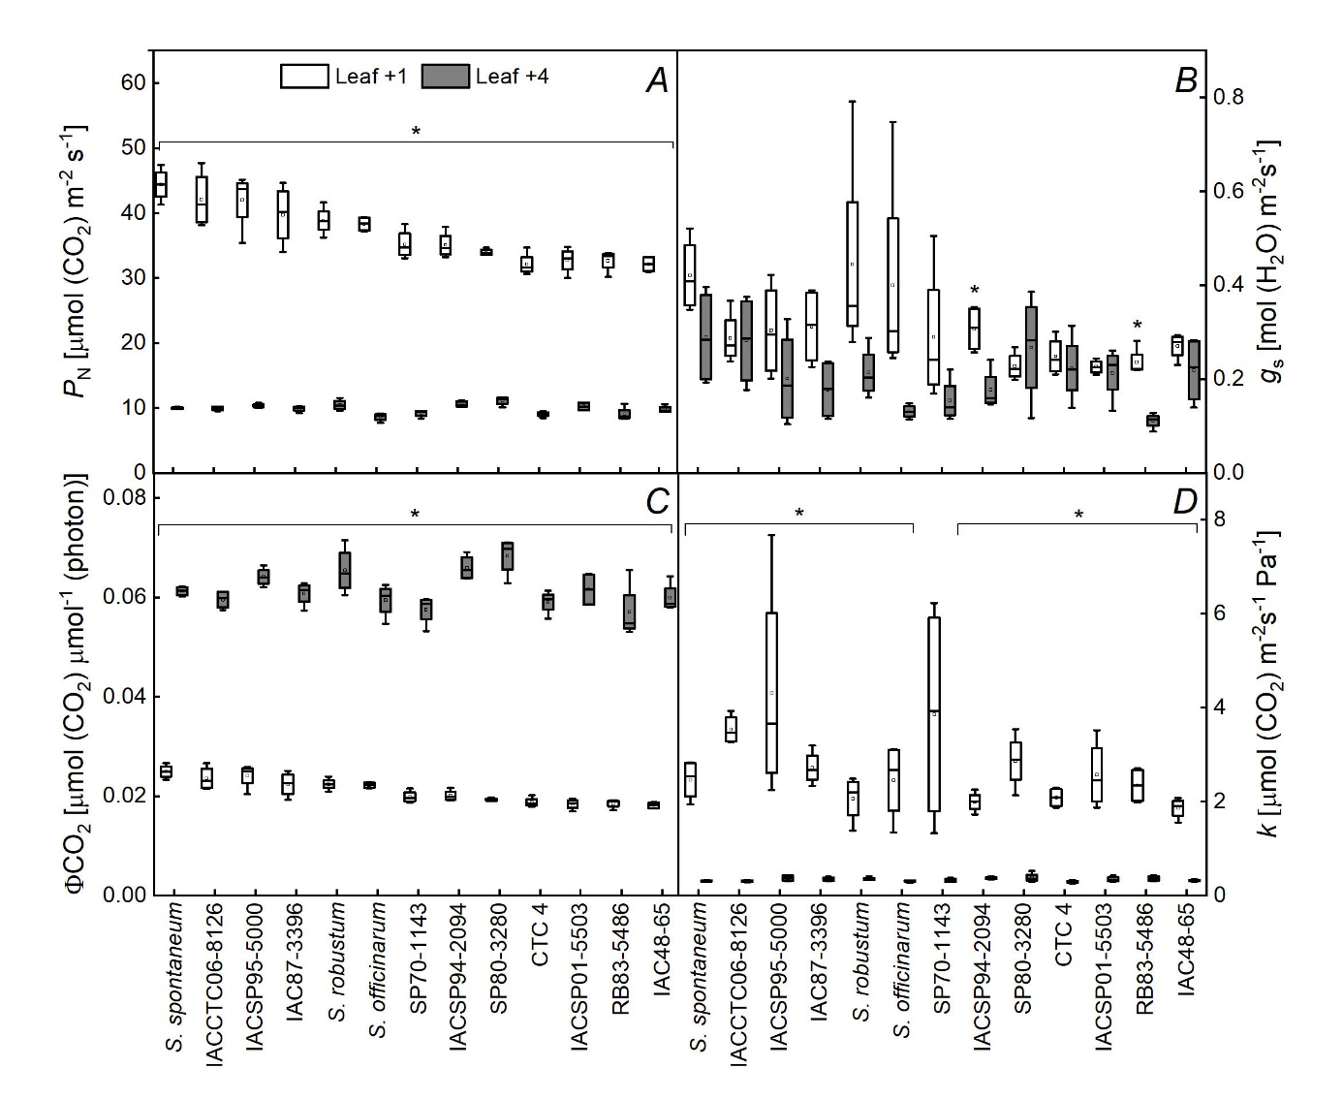

Fig. 3S. Photosynthetic rate (P_{N}) (A), stomatal conductance (g_{s}) (B), instantaneous CO₂ quantum efficiency (Φ_{CO2}) (C), and instantaneous carboxylation efficiency (k) (D) in leaves +1 under high light [index ‘H’, Q = 2,000 μmol(photon) m^{–2} s^{–1}] and +4 under low light [index ‘L’, Q = 200 μmol(photon) m^{–2} s^{–1}] of thirteen sugarcane genotypes. * indicates a difference between leaf +1 and +4 (BF₁₀ > 3, n = 4).

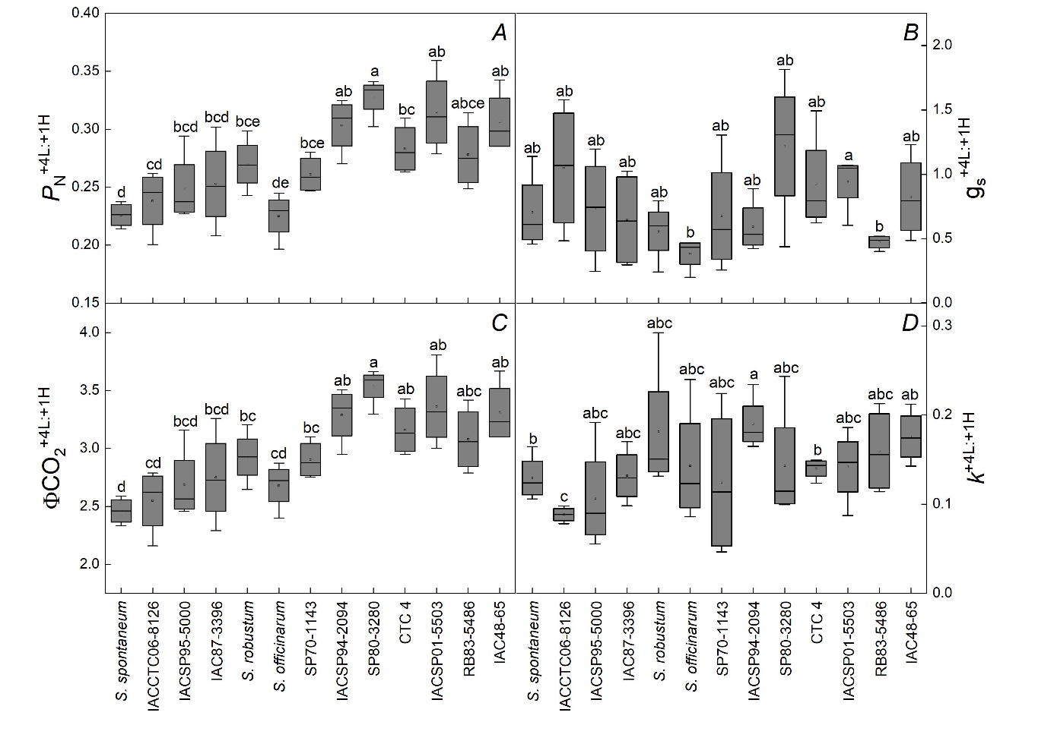

Fig. 4S. Ratios of photosynthesis (P_{N}^{+4L:+1H}), stomatal conductance (g_{s}^{+4L:+1H}), instantaneous CO₂ quantum efficiency (Φ_{CO2}^{+4L:+1H}), and instantaneous carboxylation efficiency (k^{+4L:+1H}) in leaf +4 under low light [index ‘L’, Q = 200 μmol(photon) m^{–2} s^{–1}] and leaf +1 under high light [index ‘H’, Q = 2,000 μmol(photon) m^{–2} s^{–1}] of thirteen sugarcane genotypes. Different letters indicate statistical differences among genotypes (BF₁₀ > 3, n = 4).

