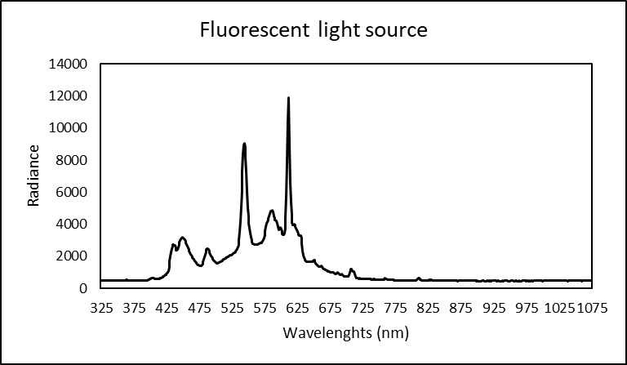

Fig. 1S. Spectra of the fluorescent light source used in this study to induce greening of potato tubers.

Table 1S. List of gene IDs, names, abbreviations and primers used for quantitative real-time PCR in this study.

Gene ID | Transcript ID | Gene abbreviation | Gene name | Forward primer (5’-3’) | Reverse primer (5’-3’)
102596523 | PGSC0003DMT400016326 | HEMA1 | Glutamyl-tRNA reductase 1 | GCTGTGGAGTTGGCTCTGAT | TTGTGCATCCCTTGGCTACC
102589658 | PGSC0003DMT400080033 | HEMA2-Like | Glutamyl-tRNA reductase 2-like | AAAGGGTGCCTGGATTTGGT | TGTGTTTCAGCAGAGCAAGC
102593524 | PGSC0003DMT400082448 | GSA | Glutamate-1-semialdehyde 2,1-aminomutase | AACGAGTTTCGGTGCTCCAT | GGCAAGTAAAAGCACGAGCC
102604643 | PGSC0003DMT400075960 | HEMB | Delta-aminolevulinic acid dehydratase | TCACATCTTTGGCTCAATTTTGCT | AAGGTGCGTTCAACATTGCC
102580720 | PGSC0003DMT400056896 | HEMC | Porphobilinogen deaminase | TTGGGTTTTCTTCGCCTTGC | GGCTTCCTCGTGTTCCAACT
102581448 | NA? | HEMD | Uroporphyrinogen-III synthase | GTCACCGTTTCGTGTTCGAC | GTGCATGTGCTGAATGAGAGG
102582223 | PGSC0003DMT400070975 | HEME | Uroporphyrinogen decarboxylase | TCAGGTGGCTTGCTTGAGAG | GCCACATTAGGACCCAGTCG
102600601 | PGSC0003DMT400029316 | HEMF | Coproporphyrinogen-III oxidase | TGGCAACAATTACGGAGGGG | ATGGTCGTACTCCCAACGTG
102583969 |  | HEMG | Protoporphyrinogen oxidase | ACTATCCCCCAGTAGCAGCA | GATGCAACTGCCCAAATCCC
102605088 | PGSC0003DMT400070176 | CHLH | Magnesium-chelatase subunit H | CTCTGGTGCTTTGGGGAACA | CAAGTGTGTCAGCAACTGGC
102584630 |  | CHLD | Magnesium-chelatase subunit D | TTCGATGCGGAAGGTGGTTT | GACCCTTTGGAAGCATTGGC
102591731 | PGSC0003DMT400068480 | CHLI | Magnesium-chelatase subunit I | AGTAATGAGCGCCGAAGTCC | ATTGTCCCACACACCCTGTC
102580238 | PGSC0003DMT400036941 | CHLM | Magnesium protoporphyrin IX methyltransferase | CCGGTTGTTTGTCGATTCCG | AACTCCTCTTGCGCCTGTTT
102600334 | PGSC0003DMT400018519 | CRD | Magnesium-protoporphyrin IX monomethyl ester cyclase | GGTCTCGCTTCTTCTGCCTT | ACCTGCATTTTGGTAAGCACA
102599631 | PGSC0003DMT400047263 | POR | NADPH:protochlorophyllide oxidoreductase | GGCCACTTGATGCGCTAGTA | AGTTCAAATCCGTCAGCCGT
102602338 | PGSC0003DMT400058379 | DVR | divinyl chlorophyllide a 8-vinyl-reductase | TGCAAGCCGATAAGTGAGCA | TGTCAATGCCTTCCCAGGTC
102580726 | PGSC0003DMT400021854 | CHLG | Chlorophyll synthase | TAGGGCTATGGGGCTTCAGT | AGGGTTTGCCAGCACCTAAA
102592765 | PGSC0003DMT400045300 | CAO | Chlorophyllide a oxygenase | ATCTGAGGTGCGGGTTTCTG | GGGGGATGAAGACGTGGAAA
102587437 | PGSC0003DMT400030256 | HCAR | 7-hydroxymethyl chlorophyll a reductase | GTAAGCGGCGTCCATTTGTC | GGAGCAGGTTGAGAAGGACC
102584485 | PGSC0003DMT400056145 | CLH | Chlorophyllase | ACCTCCACAAAGTCGCAGTC | ATGGATTCGCCCTTGCTACC
102601206 | PGSC0003DMT400077670 | NYC | Chlorophyll(ide) b reductase NYC1 | GGAGGATCTAGCACCCCTCT | GGTTAGGACCATGCCTGGAG
102594861 | PGSC0003DMT400038088 | NOL | Chlorophyll(ide) b reductase NOL | ATCTGTCGCCTGGAATGGTC | AACCACATCTGCTGGCTCTG
102602388 | PGSC0003DMT400011653 | PPH | Pheophytinase | GCAAACAGGTCAACATCAATCAC | CTACACCAAGCTCACGAGGA
102579316 | PGSC0003DMT400001216 | PAO | Pheophorbide A oxygenase | TCTGGACCTTGGGGTTTTGC | ACCCACTTCTGATCACCCAC
102591737 | PGSC0003DMT400048861 | RCCR | Red chlorophyll catabolite reductase | TCACTGCAACCTACCCACAG | GTTGGACTGCTGCGGATAAC

Table 2S. Summary of two-way ANOVA on the effects of treatment (Variety) and time (T) and their interaction (V × T). n =3. *P<0.05; **P<0.01; ***P<0.001; ns, not significant.

Gene | Variety | Time | V × T
HEMA1 | *** | *** | ***
HEMA2-like | ** | ns | ns
GSA | *** | *** | ***
HEMB | *** | *** | ***
HEMC | *** | *** | ***
HEMD | * | *** | ***
HEME | *** | *** | ***
HEMF | ns | *** | *
HEMG | *** | *** | ***
CHLH | *** | *** | ***
CHLD | *** | *** | ***
CHLI | *** | *** | ***
CHLM | ** | *** | *
CRD | *** | *** | ***
POR | *** | *** | ***
DVR | *** | *** | ***
CHLG | ns | ns | ns
CAO | ns | ns | *
HCAR | *** | *** | *
NYC | ** | *** | ns
NOL | ns | *** | ns
CLH | *** | *** | ***
PPH | *** | *** | **
PAO | * | *** | ns
RCCR | *** | ** | *

