Supplementary data

Response of leaf internal CO₂ concentration and intrinsic water use efficiency in Norway spruce to century-long gradual CO₂ elevation

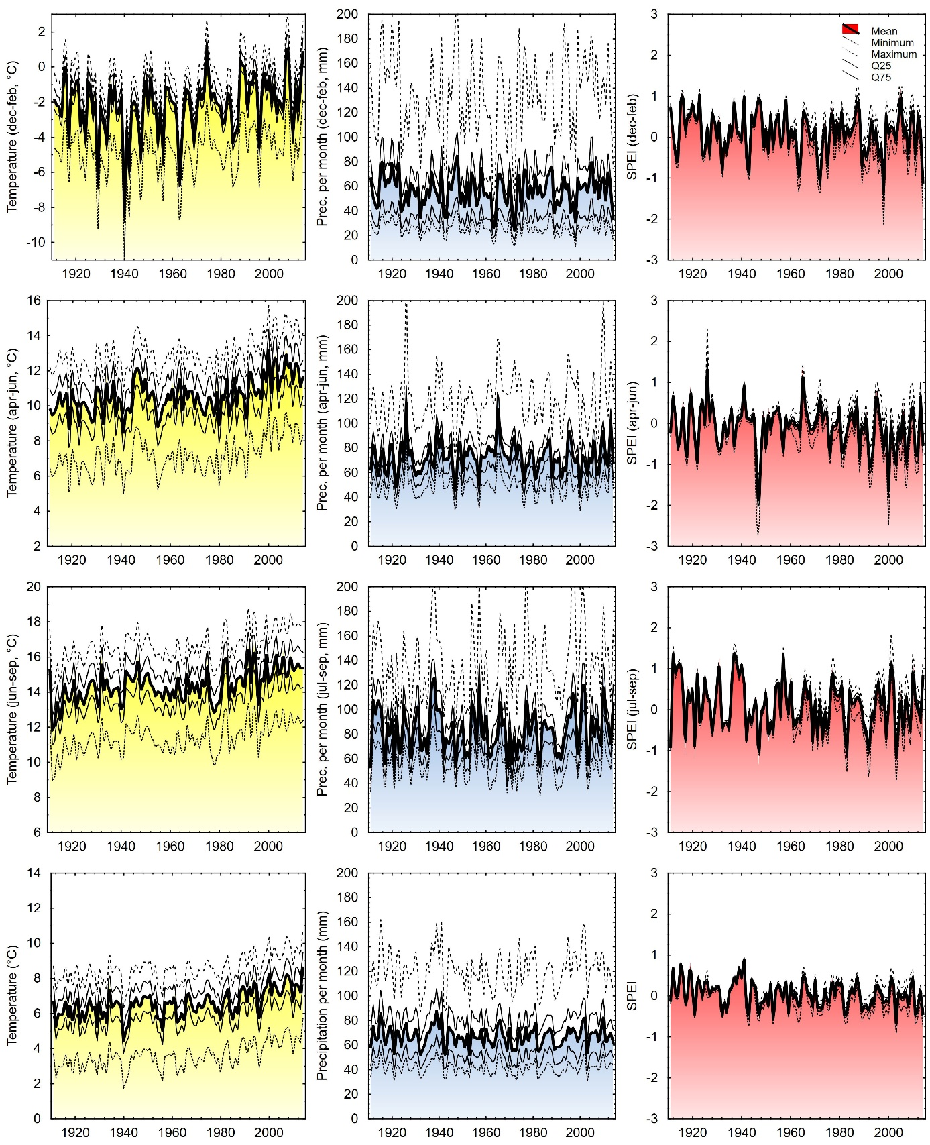

Fig. 1S. Hundred-year courses of temperature, precipitation, and SPEI in Central Europe (Czech Republic). Means, 25th and 75th quantiles and extremes are shown for winter (upper row of panels), spring (2nd row), summer (3rd row) and the whole year (bottom row). A set of measured and/or approximated data for our 51 spruce sampling sites (see Fig. 1 for their locations) was used for the calculations.
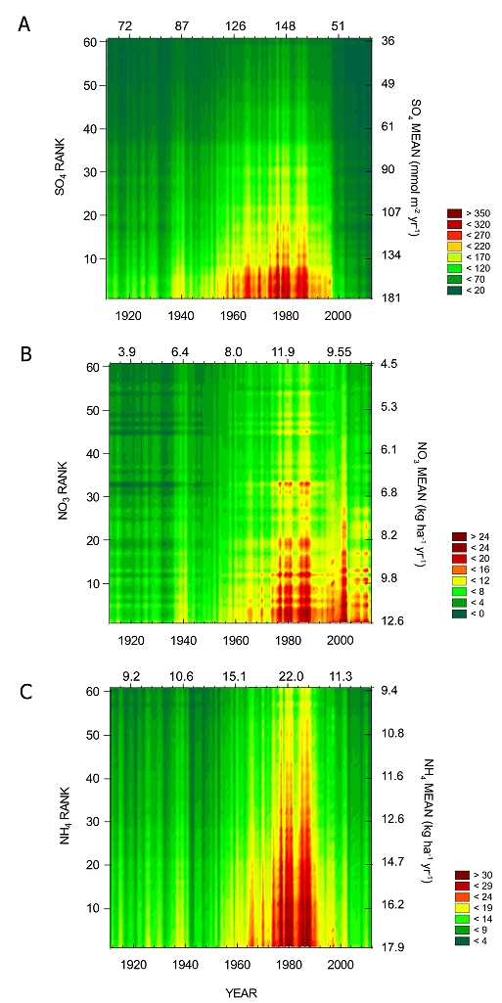

Fig. 2S. Wafer plots of annual deposition rates of SO₄^{2–} (A), NO₃– (B,) and NH₄⁺ (C) for 60 locations sampled in this study. Colours indicate annual deposition rates for the period 1910–2014 and particular locations ranked in descending order of the deposition rates (left axis): the location with the highest average deposition rate is ranked 1, the lowest one 60. The means calculated across all 60 locations for each year (in 20-year steps) are shown along the top of each panel. The means calculated across all years for any particular location (in 10-rank steps) are indicated along the right of each panel.

Fig. 3S. Time course of tree-ring δ¹³C of late-wood cellulose isolated from 57 Norway spruce trees. The medians and 10-year moving averages (solid and dashed bold lines, respectively) are shown together with minima, maxima, 25% and 75% percentiles (finer lines; for patterns see inset) calculated for each year and all tree-ring series (cores).
Fig. 4S. Wafer plots of intrinsic water-use efficiency (WUE_{i}) inferred from δ¹³C in tree ring cellulose deposited between 1914 and 2014 in spruce trees grown at altitudes from ∼260 to 1060 m a.s.l. The trees are separated in two groups, one characterized by a quasi-linear time course of Δ¹³C (Response Type 1, RT1, left) and the other exhibiting a nonmonotonic Δ¹³C time course with a minimum in the 1970s-1990s (Response Type 2, RT2, right). Colors denote WUE_{i} (µmol mol^{–1}) extrapolated from the individual data points, dots in lines indicate tree ring samples dissected from wood cores.

Fig. 5S. Tree-ring width (A,B) and tree-ring width residuals (C,D) of Norway spruce in the last hundred years. Spruce trees were classified into two Response Types, RT1, with linear increase of intrinsic water-use efficiency (WUE_{i}) and RT 2 with saturating increase of WUE_{i}. Annual means (A,C) and standard deviations SD (B,D) of trees-ring width in any particular RT and year are shown (maximum number of trees n_{max} = 22 and 35 in RT1 and RT2, respectively). Residuals were calculated for each tree as the difference between the 10-year moving average and the ring width (C) or SD (D) in the given year.
Fig. 6S. Three indicators of C_{i} control (C_{i}, C_{i}/C_{a}, C_{a} – C_{i}) plotted against C_{a} for three periods of the last hundred years of spruce tree ontogeny. The figure indicates how the strategy of C_{i} control for three distinctive periods was determined, using tree no. ID 66 as an example. In each period, we were looking for statistically nonsignificant changes in one of the parameters C_{i}, C_{i}/C_{a} or C_{a} – C_{i}, using the probability values (p) of linear regression. The parameter which did not correlate with C_{a} was determined (red points and regression lines) for each single tree and each period.
Fig. 7S. Schematic response of intrinsic water-use efficiency (WUE_{i}) and photosynthetic rate (A) to increasing C_{a} in the situation when C_{i} is concomitantly reduced. Decreasing leaf internal CO₂ concentration C_{i} at increasing atmospheric CO₂ concentration C_{a} (s < 1 in the inset of A) requires the decline of both photosynthetic rate and stomatal conductance (B), assuming that parameters of the A vs. C_{i} curve (shape of the curve in B) do not change with elevating C_{a}. If that is the case, WUE_{i} plotted against C_{a} increases with the slope l > 1/1.6 (the bold line in A).
Fig. 8S. Standard deviations (SD) of Δ¹³C values estimated for particular C_{a} values occurring between 1919 and 2014. SD of Δ¹³C in RT1 trees (blue points and line) was steady during the last hundred years while in RT2 trees (red symbols) it was significantly lower and increased toward the present time.

Table 1S. Slopes of the CO₂ response of WUE_{i} (l) and CO₂ response of C_{i} (s) of Norway spruce trees during three time periods with different ambient CO₂ ranges (C_{a}). Slopes l and s are defined as l = dWUE_{i}/dC_{a}, s = dC_{i}/dC_{a}, C_{a} is in μmol mol^{–1}. Distinctly different patterns of the CO₂ responses are denoted as Response Types (RT) 1 and 2. Both are subdivided into three groups according to the elevation of the growth sites. n is the number of trees investigated in the given RT and elevation range. n.d. indicates categories with only one tree.

RT | Altitude  (m a.s.l.) No of trees No of samples | 1919–1974 |  | 1975–1994 |  | 1995–2014
RT | Altitude  (m a.s.l.) No of trees No of samples | C_{a} 305–330 |  | C_{a} 331–359 |  | C_{a} 361–402
RT | Altitude  (m a.s.l.) No of trees No of samples | l | s | l | s | l | s
1  (n = 22) | >700 n = 3-6 169 | 0.352 | 0.437 | 0.368 | 0.411 | 0.338 | 0.459
1  (n = 22) | 400-700 n = 9-14 965 | 0.566 | 0.163 | 0.688 | –0.101 | 0.234 | 0.626
1  (n = 22) | <400 n = 1-2 103 | n.d. | n.d. | 0.343 | 0.452 | 0.373 | 0.403
mean (slope of regression line through annual averages) |  | 0.427 | 0.317 | 0.574 | 0.144 | 0.295 | 0.504
2  (n = 35) | >700 n = 9–12 209 | 1.282 | –1.052 | 0.410 | 0.344 | 0.070 | 0.888
2  (n = 35) | 400-700 n = 16–18 914 | 0.911 | –0.429 | 0.376 | 0.399 | 0.152 | 0.757
2  (n = 35) | <400 n = 4–5 209 | 1.231 | –0.969 | 0.265 | 0.576 | –0.075 | 1.120
mean (slope of regression line through annual averages) |  | 1.124 | –1.000 | 0.375 | 0.400 | 0.079 | 0.873

Source of possible errors in WUE_{i} measurements

The carbon isotope method employed for estimating C_{i} assumes that C_{i} is identical to the CO₂ concentration in chloroplasts (C_{c}) and ¹³C discrimination during respiration and photorespiration is negligible. This assumptions are used in the simplified linear model relating Δ¹³C to C_{i}/C_{a} in Eq. 2 (Farquhar et al. 1982). However, Δ¹³C is proportional to C_{c} rather than to C_{i} and, therefore, is affected by mesophyll conductance (g_{m}) in addition to g_{s}. Depending on plant species, photosynthetic rate and stomatal conductance, WUE_{i} calculated using the linear model can overestimate the real WUE_{i} value by up to 20%. Furthermore, the change of WUE_{i} due to stomatal closure can vary (0–10%) depending on which of the scenarios of C_{i} control shown in Fig. 2 applies (Seibt et al. 2008). The WUE_{i} variations found here, which may be attributed to changing g_{s}, reached up to 53% in RT2 or were relatively small and steady for many decades in RT1. Large or systematic long-term changes of mesophyll conductance are unlikely; however, reliable data for g_{m} and its response to C_{a} in spruce are missing so far.
Another source of errors stems from the fact that carbon isotope composition of newly assimilated sugars in leaves deviates from the isotopic composition of wood and cellulose deposited in the trunk. The average difference in δ¹³C between relatively depleted leaves and enriched heterotrophic plant tissues calculated from more than 80 studies was 1.26‰ (Badeck et al. 2005). Gessler et al. (2009) and Brandes et al. (2007) found that water-soluble sugars in the phloem of Scots pine trunks were enriched in ¹³C by 1.2‰ and 1.5‰, respectively, compared with the sugars in needles. We applied corrections for the post-photosynthetic discrimination proportionally to the magnitude of δ¹³C in spruce cellulose according to Gebauer and Schulze (1991). The calculated δ¹³C of needle sugars was lower by 1.36 ± 0.05‰ than in cellulose in the trunk. Wood and cellulose are usually further enriched in ¹³C than phloem sugars [e.g., by 1.4‰ in Pinus radiata (Barbour et al. 2002) and 0.8‰ in Eucalyptus globulus (Cernusak et al. 2005)]; however, the late wood was reported to be strongly depleted compared with early wood in broad-leaf trees (Helle and Schleser 2004) and rather less depleted in conifers (Jäggi et al. 2002, Vaganov et al. 2009).

References

Badeck F.-W., Tcherkez G., Nogués S. et al.: Post-photosynthetic fractionation of stable carbon isotopes between plant organs – a widespread phenomenon. – Rapid Commun. Mass Sp. 19: 1381-1391, 2005.
Barbour M.M., Walcroft A.S., Farquhar G.D.: Seasonal variation in δ¹³C and δ¹⁸O of cellulose from growth rings of Pinus radiata. – Plant Cell Environ. 25: 1483-1499, 2002.
Brandes E., Wenninger J., Koeniger P. et al.: Assessing environmental and physiological controls over water relations in a Scots pine (Pinus sylvestris L.) stand through analyses of stable isotope composition of water and organic matter. – Plant Cell Environ. 30: 113-127, 2007.
Cernusak L.A., Farquhar G.D., Pate J.S.: Environmental and physiological controls over oxygen and carbon isotope composition of Tasmanian blue gum, Eucalyptus globulus. – Tree Physiol. 25: 129-146, 2005.
Farquhar G.D., OꞌLeary M.H., Berry J.A.: On the relationship between carbon isotope discrimination and the intercellular carbon dioxide concentration in leaves. – Aust. J. Plant Physiol. 9: 121-137, 1982.
Gebauer G., Schulze E.-D.: Carbon and nitrogen isotope ratios in different compartments of a healthy and a declining Picea abies forest in the Fichtelgebirge, NE Bavaria. – Oecologia 87: 198-207, 1991.
Gessler A., Brandes E., Buchmann N. et al.: Tracing carbon and oxygen isotope signals from newly assimilated sugars in the leaves to the tree-ring archive. – Plant Cell Environ. 32: 780-795, 2009.
Helle G., Schleser G.H.: Beyond CO₂-fixation by Rubisco – an interpretation of ¹³C/¹²C variations in tree rings from novel intra-seasonal studies on broad-leaf trees. – Plant Cell Environ. 27: 367-380, 2004.
Jäggi M., Saurer M., Fuhrer J., Siegwolf R.: The relationship between the stable carbon isotope composition of needle bulk material, starch, and tree rings in Picea abies. – Oecologia 131: 325-332, 2002.
Seibt U., Rajabi A., Griffiths H., Berry J.A.: Carbon isotopes and water use efficiency: sense and sensitivity. – Oecologia 155: 441-454, 2008.
Vaganov E.A., Schulze E.-D., Skomarkova M.V. et al.: Intra-annual variability of anatomical structure and δ¹³C values within tree rings of spruce and pine in alpine, temperate and boreal Europe. – Oecologia 161: 729-745, 2009.

