Supplementary materials

Characterization of experimental plants

Maize (Zea mays) is an annual monocotyledonous plant of the Poaceae family. Maize is native to Central and South America. Today, it is widespread across the globe and is one of the most widely grown crops in the world. On a global scale, Z. mays is cultivated on some 200 million hectares [rounded value – Erenstein et al. (2022) with annual production that exceeds 1 billion metric tons (García-Lara and Serna-Saldivar 2019)]. Maize is an important model organism used in genetic and developmental biology. Genetically engineered maize is grown in the USA, Canada and other countries. In the food industry, maize is used as a vegetable and also as a source of oil, starch, glucose, fructose syrup and bioethanol. The grain is mainly used as food, in developed countries it is mainly a staple foodstuff. In our study, we used the LOKATA C1 variety - for more details, see the Cultivation and handling of evaluated species.

Solanum lycopersicum is a perennial thermophilic herb belonging to the Solanaceae family. It is native to South America. In Europe, and worldwide, S. lycopersicum is most often grown as an annual herb as it is one of the most important vegetable plants in the world (see The Food and Agriculture Organization). Today, in agriculture, a huge number of varieties are grown and intensive breeding activities are ongoing to develop new tomato varieties (Tiwari et al. 2022) in order to meet the growing demand for fruit and vegetables. It contains the valuable carotenoids lycopene and tetraterpene, which counteract cardiovascular diseases. The mature fruit of S. lycopersicum does not contain poisonous alkaloids as many Solanaceae do. The species is rich in calcium, selenium, potassium and vitamins A, B, C and E. In our experiments, we used the variety, SHORT CHERRY (F1 hybrid, specification: Rapido). For more details see Cultivation and handling of evaluated species.

Musk mallow (Malva moschata) is a promising forage plant increasingly used in fodder mixtures in Central Europe. It belongs to the Malvaceae family, the taxonomy of which has recently been studied using molecular biology markers (García et al. 2009) and Inter-Simple Sequence Repeat (Issr) markers (Ghafoor and Hamarashid 2022). M. moschata is a medicinal plant with a high content of polysaccharides (Schmidgall et al. 2000), flavonoids, carotenoids (Redzić et al. 2005) and other biologically active compounds. A new variety of M. moschata, ROKYT, was registered in 2023 for use in Europe and is utilized in the development of forage landscape mixtures for the restoration and reseeding of meadows and pastures. The species response to environmental factors such as, for example, the biology of flowering in response to microclimatic factors (Wróblewska 2009) and its resistance to herbicide application (Lang et al. 2023) have been studied in the last decade. However, the drought resistance of the species, as well as its photosynthetic characteristics are generally unknown.

Polytrichum strictum is a moss species which can be found worldwide that tolerates a wide range of environments and conditions and is considered to be frost-tolerant (Goeneveld and Rochefort 2005). The anatomical structure of P. strictum and Polytrichum sp. leaves differ from other species as they possess photosynthetic lamellae on the upper surface of their leaves (Giudici 2019). Such structures increase the surface area and allow humid air to be trapped by thick-walled cells which minimizes water loss and optimizes photosynthesis (Thomas et al. 1996). Based on a gas-exchange study (Rzepka and Sharek 2021), Polytrichum sp. is considered to be relatively resistant to desiccation. When desiccating, the leaves curve and twist around the main axis in order to avoid fast water loss. P. strictum is a species that is abundant in maritime Antarctica. It is a dominant species that forms moss banks, as reported by Wierzgoń et al. (2023) on Galindez island, where the samples used in our study were collected.

Hypogymnia physodes is a chlorolichen of the Parmeliaceae family which is distributed worldwide distribution and is highly abundant in the Northern Hemisphere, the Circumpolar Arctic, boreal and montane, in Northern Asia, North America, and Europe. H. physodes is an epiphytic lichen with a foliose morphotype thallus that typically grows on the branches and bark of spruce trees in European forests. The physiological and photosynthetic characteristics of the species have been investigated in several studies focused on UV-B protection (Solhaug et al. 2009) based on depsidon synthesis (Studzińska-Sroka and Zarabska-Bożjewicz 2019), photosynthetic CO₂ uptake as dependent environmental factors (Osyczka and Myśliwa-Kurdziel 2023), resistance of primary photosynthetic processes to photoinhibition (Manrique et al. 1993) and dehydration (Barták et al. 2000).

Marchantia polymorpha is one of the most widespread liverworts having an almost circumpolar distribution. It forms dark green flat thalli of a foliose morphotype. The thallus may reach a length/width of up to 10/2 cm and is attached to the substrate by rhizoids. The thallus is dichotomously branched. Recently, M. polymorpha has attracted scientific attention as it is a promising model system for experimental plant biology (Shimamura 2016). Studies focused on the photosynthetic performance of M. polymorpha have addressed several aspects ranging from the daily course of photosynthetic processes (Cuitun‐Coronado et al. 2022), an evaluation of the role of flavodiiron proteins in photorespiration (Shimakawa et al. 2021), to the resistance of the species to desiccation based on the osmotic stress-induced production of antioxidants (Ghosh et al. 2021).

Dwarf pine (Pinus mugo L.) is an extremely heliophilous pioneer shrub that is native up to the timberline in the mountains of Central Europe, up to an altitude of about 2,700 m (Boratyńska et al. 2015). Pinus mugo is highly resistant to various types of stressors (Visakorpi et al. 2024). As it is a heliophilous species, it contains large amounts of carotenoids and a PSII photoinactivation strategy (reversible decrease in PSII photochemical efficiency) used by dwarf pine to resist photoinhibition (Robakowski 2011, Nouri et al. 2023). It also has a very economical water regime and a high relative water content in the needles (when compared to other pine species), therefore Pinus mugo is considered to be resistant to drought and needle desiccation (Anev and Tzvetkova 2018).

The Lebanese cedar (Cedrus libani A. Rich) is a slow-growing tree (Khuri et al. 1999, Pijut 2000) native to the mountains of the Eastern Mediterranean, Cyprus, Turkey, Syria and Lebanon (López-Tirado et al. 2021) up to an altitude of about 2,100 m (Messinger et al. 2015). Cedrus libani is very adaptable to extreme climatic conditions (Višnjić et al. 2022). In response to drought and high temperatures net photosynthesis is reduced through a decrease in stomatal conductance while the photochemical activity of photosystem II remains almost constant for a relatively long time (Deligoz et al. 2016). Therefore, resistance to high temperature and photoinhibition is reported for C. libani under drought stress (Ladjal et al. 2000, Zsolnay et al. 2023).

Composition of growth substrate

Growth substrate (used for Malva moschata cultivation) had the following composition: 70% white peat, 30% black peat and 20 kg m⁻³ bentonite. Its chemical characteristics are as follows: pH (H₂O) 5.5–6.5, N 190 ± 20 mg L⁻¹, P₂O₅ 200 ± 18 mg L⁻¹ and K₂O 220 ± 23 mg L⁻¹.

Table 1S. Initial slope of the NPQ increase during the induction phase (alpha [α]) and the decrease in NPQ at the very beginning of the dark period (beta [β]), evaluated as ΔNPQ/Δtime(s) for the initial part of induction and relaxation (see Fig. 1 for definition). The α and β parameters are presented for RWC classes in all experimental species.

RWC |  | Z. mays | S. lycopersicum | M. moschata | P. strictum | H. physodes | M. polymorpha | P. mugo | C. libani
95% | α  β | 0.018±0.0017^{b}  0.027±0.0018ª | 0.051±0.0049ª  0.010±0.0009ª | 0.022±0.0021^{b}  0.012±0.0011ª | 0.056±0.0052^{b}  0.025±0022ª | 0.022±0.0019^{b}  0.004±0.0004ª | 0.045±0.0042ª  0.008±0.00076ª | 0.051±0.0050ª  0.018±0.0017ª | 0.020±0.0018ª  0.002±0.0002ª
60% | α  β | 0.036±0.0032ª  0.017±0.0015^{b} | 0.042±0.0041^{b}  0.004±0.0003^{b} | 0.034±0.0031ª  0.011±0.0009ª | 0.074±0.0068ª  0.017±0.0016^{b} | 0.038±0.0033ª  0.004±0.00038ª | 0.031±0.0030^{b}  0.006±0.0005^{b} | 0.030±0.0029^{b}  0.001±0.00009^{b} | 0.014±0.0015^{b}  0.002±0.00018ª
25% | α  β | 0.017±0.0015^{b}  0.008±0.0007^{bc} | 0.003±0.00027^{c}  - | 0.007±0.0066^{c}  0.002±0.00016^{b} | 0.013±0.0014^{c}  0.002±0.00017^{c} | 0.023±0.0021^{b}  0.002±0.00019^{b} | 0.014±0.0013^{c}  0.001±0.00012^{c} | 0.020±0.0021^{c}  0.001±0.0001^{b} | 0.008±0.0007^{c}  0.001±0.00009^{b}
10% | α  β | 0.015±0.0013^{b}  0.005±0.0004^{c} | 0.002±0.0002^{c}  - | 0.003±0.0031^{c}  - | 0.008±0.0007^{d}  - | 0.009±0.0008^{c}  - | 0.004±0.0003^{d}  - | 0.001±0.0001^{d}  - | 0.003±0.0027^{d}  -

Table 2S. Decrease of photosynthetic electron transport rate (maximum value of ETR_{max} found during the induction phase for the light period) and its dependence on desiccation (RWC classes) from a water content of 100% (RWC = 100%) to a dry state (RWC = 0%). The mean values ± standard deviation (SD) are presented.

RWC | Z. mays |  | S. lycopersicum |  | M. moschata |  | P. strictum |  | H. physodes |  | M. polymorpha |  | P. mugo |  | C. libani
100.0%–90.0 % | 36.83ª | ±15.76 | 22.05ª | ±5.00 | 30.38ª | ±17.12 | 14.08ª | ±1.68 | 24.38ª | ±10.02 | 14.33ª | ±3.24 | 51.23ª | ±8.11 | 20.80ª | ±6.39
89.9%–80.0 % | 20.18^{ab} | 2.77 | 20.98ª | 4.30 | 30.15ª | 2.45 | 15.31ª | 2.55 | 31.00ª | 3.07 | n.d. | n.d. | 37.10ª | 7.42 | 9.80ª | 6.01
79.9%–70.0 % | 15.50^{b} | 2.77 | 19.79ª | 3.18 | 36.05ª | 0.85 | 15.75ª | 2.38 | 35.20ª | 3.48 | 16.70ª | 3.34 | 36.30ª | 7.26 | n.d. | n.d.
69.9%–60.0 % | 14.65^{b} | 3.80 | 17.58ª | 3.08 | 36.20ª | 1.70 | 16.05ª | 2.11 | 31.20ª | 3.09 | 16.55ª | 8.05 | n.d. | n.d. | 17.00ª | 10.02
59.9%–50.0 % | 9.07^{bc} | 3.49 | 13.73ª | 4.13 | 31.18ª | 6.48 | 15.92ª | 1.41 | 32.80ª | 3.86 | 10.55^{b} | 1.05 | 36.98ª | 7.13 | 15.00ª | 9.01
49.9%–40.0 % | 5.78^{bc} | 2.22 | 11.57^{ab} | 2.58 | 25.75ª | 13.07 | 16.33ª | 2.07 | 25.70ª | 2.54 | 21.00ª | 4.20 | 30.80^{ab} | 4.40 | 5.15^{ab} | 5.05
39.9%–30.0 % | 7.43^{bc} | 6.71 | 6.12^{b} | 5.23 | 20.30ª | 8.07 | 15.47ª | 2.97 | 21.35ª | 1.95 | 5.40^{c} | 1.00 | 30.47^{ab} | 7.07 | 4.30^{ab} | 4.23
29.9%–20.0 % | 2.20^{bc} | 2.24 | 5.68^{b} | 3.87 | 15.06^{b} | 5.07 | 7.91^{b} | 0.80 | 23.37ª | 2.29 | 6.35^{bc} | 5.65 | 17.14^{ab} | 13.28 | 3.19^{b} | 1.83
19.9%–10.0 % | 0.18^{cd} | 0.07 | 0.00 | 0.00 | 5.89^{c} | 1.98 | n.d. | n.d. | 10.97^{b} | 3.87 | 0.20^{d} | 0.19 | 12.68^{b} | 7.62 | 0.32^{b} | 0.45
9.9%–5.0 % | 1.30^{cd} | 1.39 | 0.00 | 0.00 | 1.37^{d} | 0.98 | n.d. | n.d. | 6.77^{b} | 5.05 | 0.04^{d} | 0.08 | 0.00 | 0.00 | 0.54^{c} | 0.73
4.9%–0.0 % | 0.07^{d} | 0.19 | 0.00 | 0.00 | 0.05e | 0.09 | 0.00 | 3.27 | 1.50^{c} | 1.41 | 0.00^{d} | 0.00 | 0.00 | 0.00 | 0.00^{c} | 0.00

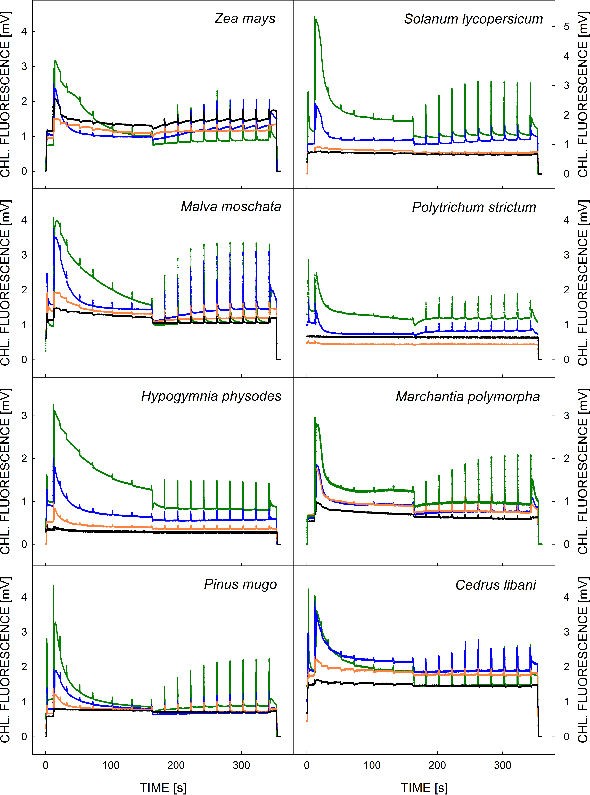

Fig. 1S. Slow Kautsky kinetics recorded during sample desiccation at relative water contents of 100, 60, 25, and 10% showing desiccation-induced decrease in chlorophyl fluorescence signal. The change is apparent as a ‘flattening’ of the Kautsky kinetics.

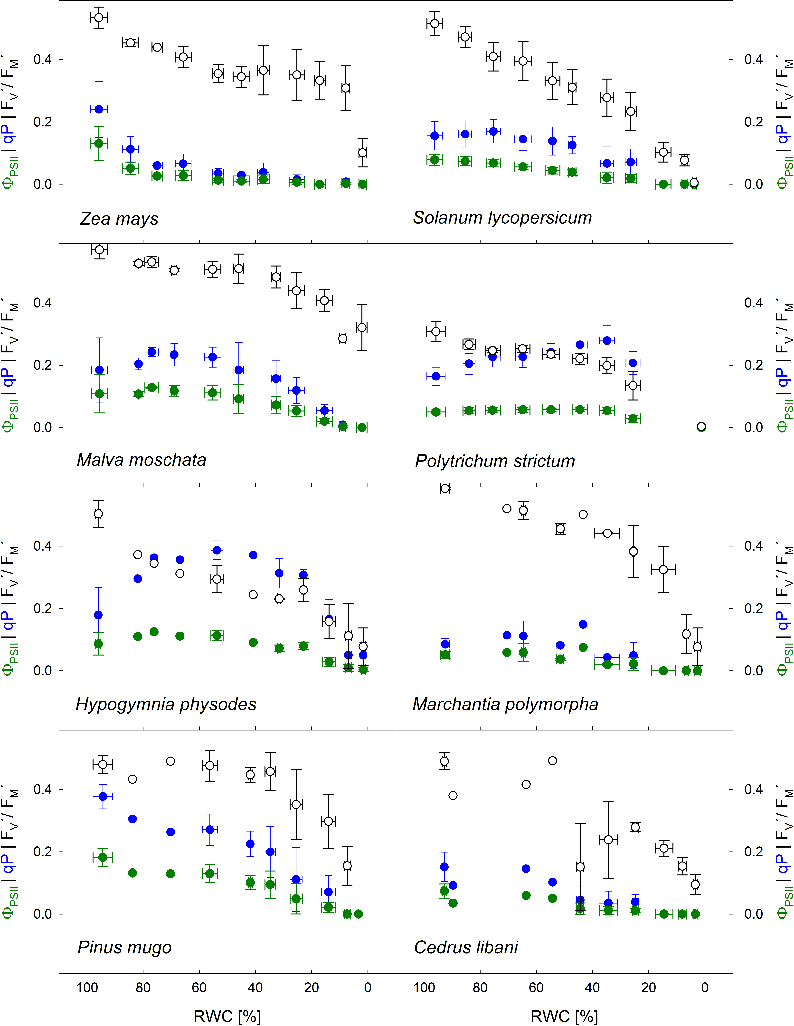
Fig. 2S. Relation of photochemical quenching (qP), effective quantum yield (Φ_{PSII}) of photochemical processes in photosystem II, and maximum quantum yield of PSII in the light-adapted state (F_{V}´/F_{M}´) to relative water content (RWC) during desiccation. Means for the RWC classes (90–100, 80–90, 70–80, 60–70, 50–60, 40–50, 30–40, 20–30, 10–20, and 0–10%). Data points represent means ± standard deviations. The reason for different courses of Φ_{PSII} is that decreasing RWC may affect the values of qP and F_{V}'/F_{M}' in a different way in particular experimental species (Φ_{PSII} = qP × F_{V}'/F_{M}').

Table 3S. Specification of origin of samples and cultivation details where appropriate.

Species | Way of cultivation / collection | Locality | Medium / substrate / site | Age of plants
Zea mays | Hydroponics | Controlled growth chamber | Hoagland solution | 5 weeks
Solanum lycopersicum | Hydroponics | Controlled growth chamber | Hoagland solution | 4 weeks
Malva moschata | Potted plants | Grown in agricultural area 10 km SW from Brno | Peat substrate | 8 weeks
Polytrichum strictum | Feld collection | Antarctica, Galindez Island | Moss banks | unknown
Hypogymnia physodes | Feld collection | Forest, 105 km NW from Brno, CZ | Bark of Norway spruce trees | unknown
Marchantia polymorpha | Feld collection | River bank, 10 km S from Brno | ground | unknown
Pinus mugo | Feld collection of shoots | Treeline, Jeseníky Mts, CZ  110 km N from Brno | Current shoots cut off the trees | unknown
Cedrus libani | Potted seedlings | Forest nursery, 30 km N from Brno | Pots on ground | 3 years-old (current needles)

Table 4S. Coefficients of an exponential fit through NPQ induction, and NPQ relaxation part, recorded during the light, and dark period, respectively, for RWC classes. The exponential fit exploited the formula shown in the upper left corner of the table. Data presented are means of four replicates standard deviations.

f=y0+a*exp(-b*x) |  | NPQ induction |  |  | NPQ relaxation
f=y0+a*exp(-b*x) |  | y0 | a | b | y0 | a | b
Zea mays | 95% | 3.2559 | -3.3541 | 0.0068 | 0.3749 | 0.6093 | 0.0415
Zea mays | 60% | 1.5345 | -1.6041 | 0.0378 | 0.1734 | 0.8209 | 0.0247
Zea mays | 25% | 0.6081 | -0.62 | 0.0254 | 0.1321 | 0.2157 | 0.0299
Zea mays | 10% | 0.4249 | -0.4331 | 0.0363 | 0.154 | 0.1238 | 0.0396
Solanum lycopersicum | 95% | 1.9751 | -2.123 | 0.0277 | 0.8122 | 0.7524 | 0.0407
Solanum lycopersicum | 60% | 0.895 | -0.949 | 0.0543 | 0.3117 | 0.4462 | 0.0124
Solanum lycopersicum | 25% | 0.1668 | -0.1697 | 0.0156 | 0.2461 | -0.0826 | 0.0021
Solanum lycopersicum | 10% | 0.1281 | -0.1269 | 0.0179 | 0.1609 | -0.0357 | 0.0092
Malva moschata | 95% | 3.1294 | -3.1946 | 0.0043 | 0.2152 | 0.7091 | 0.0388
Malva moschata | 60% | 1.485 | -1.5795 | 0.0302 | 0.2167 | 0.8797 | 0.0292
Malva moschata | 25% | 0.6195 | -0.6685 | 0.0192 | 0.2376 | 0.2582 | 0.0235
Malva moschata | 10% | 0.3278 | -0.3396 | 0.0108 | 0.189 | 0.0517 | 0.0324
Polytrichum strictum | 95% | 1.4674 | -1.5822 | 0.0310 | 0.6074 | 0.9894 | 0.0655
Polytrichum strictum | 60% | 1.5514 | -1.7077 | 0.0407 | 0.6324 | 0.8034 | 0.0478
Polytrichum strictum | 25% | 0.2267 | -0.2444 | 0.0544 | 0.1683 | 0.0527 | 0.1956
Polytrichum strictum | 10% | 0.0504 | -0.0497 | 0.0194 | - | 0.0551 | 1.80E-14
Hypogymnia physodes | 95% | 2.4760 | -2.4848 | 0.0072 | - | 1.3672 | 4.51E-15
Hypogymnia physodes | 60% | 2.1771 | -2.2195 | 0.0256 | -1.6485 | 3.6244 | 0.0002
Hypogymnia physodes | 25% | 1.2064 | -1.2046 | 0.040 | 1.1893 | -0.0186 | 0.0177
Hypogymnia physodes | 10% | 0.3744 | -0.3823 | 0.028 | - | 0.4190 | 2.63E-14
Marchantia polymorpha | 95% | 1.1539 | -1.2266 | 0.0563 | 0.3939 | 0.5074 | 0.0217
Marchantia polymorpha | 60% | 1.0086 | -1.0441 | 0.0573 | 0.4612 | 0.3854 | 0.0225
Marchantia polymorpha | 25% | 0.5394 | -0.5518 | 0.0432 | 0.4538 | 0.0673 | 0.0539
Marchantia polymorpha | 10% | 0.3243 | -0.3234 | 0.0142 | - | 0.3656 | 4.43E-14
Pinus mugo | 95% | 3.6510 | -3.8295 | 0.0189 | 1.0186 | 1.657 | 0.0306
Pinus mugo | 60% | 1.4041 | -1.4991 | 0.0265 | -0.1025 | 1.3493 | 0.0034
Pinus mugo | 25% | 0.5540 | -0.5900 | 0.0429 | 0.2939 | 0.2187 | 0.0195
Pinus mugo | 10% | 0.0758 | -0.0763 | 0.0190 | 0.2161 | -0.1456 | 0.0008
Cedrus libani | 95% | 1.0902 | -1.1655 | 0.0193 | 0.4497 | 0.5444 | 0.0072
Cedrus libani | 60% | 0.5460 | -0.5654 | 0.0352 | 0.3337 | 0.1971 | 0.0199
Cedrus libani | 25% | 0.2602 | -0.2718 | 0.0360 | 0.2027 | 0.0486 | 0.0305
Cedrus libani | 10% | 0.1143 | -0.1161 | 0.0356 | - | 0.1129 | 7.93E-13

References

Anev S.M., Tzvetkova N.P.: Drought stress in four subalpine species: gas exchange response and survivorship. – Russ. J. Ecol. 49: 422-427, 2018.
Barták M., Hájek J., Gloser J.: Heterogeneity of chlorophyll fluorescence over thalli of several foliose macrolichens exposed to adverse environmental factors: interspecific differences as related to thallus hydration and high irradiance. – Photosynthetica 38: 531-537, 2000.
Boratyńska K., Jasińska A.K., Boratyński A.: Taxonomic and geographic differentiation of Pinus mugo complex on the needle characteristics. – Syst. Biodivers. 13: 581-595, 2015.
Cuitun‐Coronado D., Rees H., Colmer J. et al.: Circadian and diel regulation of photosynthesis in the bryophyte Marchantia polymorpha. – Plant Cell Environ. 45: 2381-2394, 2022.
Deligoz A., Bayar E., Yazici N.: Responses of growth, water relations and compatible solutes contents to repeated drought stress in Cedrus libani. – Fresen. Environ. Bull. 25: 3760-3767, 2016.
Erenstein O., Jaleta M., Sonder K. et al.: Global maize production, consumption and trade: trends and R&D implications. – Food Secur. 14: 1295-1319, 2022.
FAO: The Food and Agriculture Organization (FAO). Available at: www.fao.org (accessed on 12.11.2024).
García P.E., Schönswetter P., Aguilar J.F. et al.: Five molecular markers reveal extensive morphological homoplasy and reticulate evolution in the Malva alliance (Malvaceae). – Mol. Phylogenet. Evol. 50: 226-239, 2009.
García-Lara S., Serna-Saldivar S.O.: Corn history and culture. – In: Serna-Saldivar S.O. (ed.): Corn: Chemistry and Technology. 3rd Edition. Pp. 1-18. Woodhead Publishing, Duxford 2019.
Ghafoor B.S., Hamarashid S.H.: Genetic diversity and relationships among medicinal species of Malva L. (Malvaceae) based on ISSR markers. – Bangladesh J. Plant Taxon. 29: 193-202, 2022.
Ghosh T.K., Tompa N.H., Rahman M.M. et al.: Acclimation of liverwort Marchantia polymorpha to physiological drought reveals important roles of antioxidant enzymes, proline and abscisic acid in land plant adaptation to osmotic stress. – PeerJ 9: e12419, 2021.
Giudici G.N.M.: Photoinhibition of primary photosynthetic processes in hydrated Polytrichum commune: analysis of non-photochemical quenching affecting species resistence. – Czech Polar Rep. 9: 160-169, 2019.
Goeneveld E.V.G., Rochefort L.: Polytrichum strictum as a solution to frost heaving in disturbed ecosystems: a case study with milled peatlands. – Restor. Ecol. 13: 74-82, 2005.
Khuri S., Talhouk S.N., Range H.: Cedar of Lebanon (Cedrus libani A. Rich.). – In: Farjon A., Page C.N. (Ed.): Conifers: Status Survey and Conservation Action Plan. Pp. 108. IUCN, Gland-Cambridge 1999.
Ladjal M., Epron D., Ducrey M.: Effects of drought preconditioning on thermotolerance of photosystem II and susceptibility of photosynthesis to heat stress in cedar seedlings. – Tree Physiol. 20: 1235-1241, 2000.
Lang J., Barták M., Váczi P., Hájek J.: Effect of some herbicides on primary photosynthesis in Malva moschata as a prospective plant for agricultural grass mixtures. – Agronomy 14: 10, 2023.
López-Tirado J., Vessella F., Stephan J. et al.: Effect of climate change on potential distribution of Cedrus libani A. Rich in the twenty-first century: an Ecological Niche Modeling assessment. – New Forest. 52: 363-376, 2021.
Manrique E., Balaguer L., Barnes J., Davison A.V.: Photoinhibition studies in lichens using chlorophyll fluorescence analysis. – Bryologist 96: 443-449, 1993.
Messinger J., Güney A., Zimmermann R. et al.: Cedrus libani: A promising tree species for Central European forestry facing climate change? – Eur. J. For. Res. 134: 1005-1017, 2015.
Nouri K., Nikbakht A., Haghighi M. et al.: Screening some pine species from North America and dried zones of western Asia for drought stress tolerance in terms of nutrients status, biochemical and physiological characteristics. – Front. Plant Sci. 14: 1281688, 2023.
Osyczka P., Myśliwa-Kurdziel B.: The pattern of photosynthetic response and adaptation to changing light conditions in lichens is linked to their ecological range. – Photosynth. Res. 157: 21-35, 2023.
Pijut P.M.: Cedrus – the true cedars. – Arboricult. Urban For. 26: 218-224, 2000.
Redzić S., Hodzić N., Tuka M.: Plant pigments (antioxidants) of medicinal plants Malva silvestris L. and Malva moschata L. (Malvaceae). – Bosn. J. Basic Med. Sci. 5: 53-58, 2005.
Robakowski P.: Photochemical processes in needles of overwintering evergreen conifers. – In: Maes K.J., Willems J.M. (Ed.): Photochemistry: UV/VIS spectroscopy, photochemical reactions and photosynthesis. Pp. 333-351. Nova Science Publishers, New York 2011.
Rzepka A., Sharek W.: Resistance of mosses to drying, measured by the intensity of gas exchange and the content of malate and citrate. – Ann. Univ. Paedagog. Crac. Stud. Naturae 6: 109-124, 2021.
Schmidgall J., Schnetz E., Hensel A.: Evidence for bioadhesive effects of polysaccharides and polysaccharide-containing herbs in an ex vivo bioadhesion assay on buccal membranes. – Planta Med. 66: 48-53, 2000.
Shimakawa G., Hanawa H., Wada S. et al.: Physiological roles of flavodiiron proteins and photorespiration in the liverwort Marchantia polymorpha. – Front. Plant Sci. 12: 668805, 2021.
Shimamura M.: Marchantia polymorpha: taxonomy, phylogeny and morphology of a model system. – Plant Cell Physiol. 57: 230-256, 2016.
Solhaug K.A., Lind M., Nybakken L., Gauslaa Y.: Possible functional roles of cortical depsides and medullary depsidones in the foliose lichen Hypogymnia physodes. – Flora 204: 40-48, 2009.
Studzińska-Sroka A., Zarabska-Bożjewicz D.: Hypogymnia physodes – a lichen with interesting medicinal potential and ecological properties. – J. Herb. Med. 17-18: 100287, 2019.
Thomas R.J., Ryder S.H., Gardner M.I. et al.: Photosynthetic function of leaf lamellae in Polytrichum commune. – Bryologist 99: 6-11, 1996.
Tiwari J.K., Behera T.K., Rai N. et al.: Tomato breeding for processing in India: current status and prospects. – Veg. Sci. 49: 123-132, 2022.
Visakorpi K., Manzanedo R.D., Görlich A.S. et al.: Leaf‐level resistance to frost, drought and heat covaries across European temperate tree seedlings. – J. Ecol. 112: 559-574, 2024.
Višnjić Ć., Čilaš M., Ivojević S.: [Ecological and silvicultural characteristics and the possibility of introducing Lebanese cedar (Cedrus libani A. Rich.) in BiH facing climate change.] – Naše Šume 20: 53-59, 2022.
Wierzgoń M., Ivanets V., Prekrasna-Kviatkovska Y. et al.: Moss bank composition on Galindez Island (Argentine Islands, maritime Antarctic). – Polar Biol. 46: 1235-1249, 2023.
Wróblewska A.: Study on flowering biology and seed sets of selected ornamental species from Malvaceae family. – J. Apic. Sci. 53: 29-36, 2009.
Zsolnay N., Walentowitz A., Aas G.: Impact of climatic conditions on radial growth of non-native Cedrus libani compared to native conifers in Central Europe. – PLoS ONE 18: e0275317, 2023.

